Article
Interface Stabilization of Aqueous Aluminum Batteries via Non-flammable Co-solvent

Keun-il Kim*
Academic Editor: Firstname Lastname
Received: date
Revised: date
Accepted: date
Published: date
Citation: To be added by editorial staff during production.
Copyright: © 2025 by the authors. Submitted for possible open access publication under the terms and conditions of the Creative Commons Attribution (CC BY) license (https://creativecommons.org/licenses/by/4.0/).
* School of Chemical, Biological and Battery Engineering, Gachon University, Seongnam-si, Gyeonggi-do, 13120, Republic of Korea): keunilkim@gachon.ac.kr
Abstract
Aqueous aluminum-ion batteries (AAIBs) face significant challenges due to interfacial instability and parasitic side reactions during the reversible deposition of aluminum. Here, we introduce a hybrid electrolyte incorporating triethyl phosphate (TEP), a non-flammable co-solvent that reconstructs the Al³⁺ solvation environment by suppressing water activity. This design extends the electrochemical stability window and enables uniform Al–Zn alloy formation at the anode interface. As a result, symmetric Al–Zn cells achieve over 4000 hours of stable cycling. In full-cell configurations with V₂O₅/C cathodes, the system demonstrates high capacity retention (~96% over 450 cycles at 2 A g⁻¹) and coulombic efficiency. This work underscores the potential of solvation structure engineering via functional, flame retarding co-solvent to advance the development of safe and durable aqueous electrolytes.
Keywords: Aqueous batteries; Aqueous aluminum-ion batteries; electrolytes; Aluminum anode; Alloy

1. Introduction

Aqueous aluminum-ion batteries (AIBs) have emerged as a highly promising candidate for next-generation grid-scale energy storage systems [1-5]. Unlike alkali-metal elements, e.g., lithium, sodium, etc., which face concerns regarding safety issues, scarcity and geographical concentration, aluminum (Al) is one of the most abundant metallic elements in the Earth's crust, ensuring a virtually limitless and inexpensive resource for large-scale battery production with secured safety in aqueous medium [5, 6]. Furthermore, aluminum's trivalent charge carrier boasts significantly higher theoretical capacity (2980 mAh g⁻¹ and 8046 mAh cm⁻³) than that of monovalent lithium, translating into its potential for energy-dense devices.

Early Al batteries adapted ionic liquids as electrolytes [7-10]; which, despite the advantage of non-flammability, are unsuitable for large-scale energy storage applications due to their high cost and sensitivity to the ambient moisture, necessitating complex fabrication processes. The use of aqueous electrolytes simultaneously mitigates risks associated with thermal runaway and fire hazards, while providing cost-effective alternatives for grid-scale energy storage systems [11-14]. Despite these compelling advantages, the widespread practical application of aqueous AIBs remains constrained by several fundamental challenges.

Unlike ionic-liquid electrolytes—in which the redox-active species are chloroaluminate anionic complexes (e.g., [AlCl₄]⁻/[Al₂Cl₇]⁻) [15-17] rather than Al³⁺—aqueous electrolytes contain trivalent Al³⁺ predominantly as the hexa-aqua complex, [Al(H₂O)₆]³⁺. The strong primary hydration thus imposes a substantial desolvation energy barrier [18, 19]. Moreover, given the substantially negative standard reduction potential of Al (-1.67 vs. Standard Hydrogen Electrode, SHE), the hydrogen evolution reaction (HER) is thermodynamically more favorable in aqueous solutions. Perpetual decomposition of water drives the accumulation of electrochemically inert passivation layer, mainly composed of Al₂O₃, on the surface of Al anode. The formation of this detrimental layer is directly responsible for the poor cyclability that hinders the practical application of Al-metal anode in aqueous electrolytes [20, 21]. To bypass such issues, recent research has focused on employing metal anodes capable of alloying with Al, e.g., Zn [22-24], Cu [25], Sn [26, 27], etc. Rather than acting as a mere passive electron conduit, the current collector is envisioned to actively participate in the electrochemical process through a reversible alloying/de-alloying reaction with Al ions provided by the electrolyte.

In the pursuit of stabilization of aqueous electrolytes, another research trajectory has been the introduction of organic co-solvents like acetonitrile (ACN) [24, 28-31], carbonates [32-34], dimethyl sulfoxide (DMSO) [35-37]. The primary objective is to widen the electrochemical stability window (ESW) of water-based electrolytes and to alter the solvation structure around the active charge carriers. While effective in enhancing electrochemical performance, these solvents carry substantial risks of flammability and toxicity, which are antithetical to the core safety advantage of aqueous systems.

Herein, we propose a strategy to stabilize the Al–Zn alloy anode surface by incorporating non-flammable triethyl phosphate (TEP) as a co-solvent in 1 m aluminum trifluoromethanesulfonate (Al(Otf)₃) aqueous electrolyte. Among its homologues, TEP’s molecular structure offers a distinct advantage. Shorter alkyl chains, as in trimethyl phosphate (TMP), are less effective at displacing coordinated water molecules, while longer chains, as in tributyl phosphate (TBP), result in excessive viscosity that impedes ionic conductivity. TEP’s ethyl groups thus represent an optimal balance, enabling effective solvation engineering without compromising the essential transport properties of the electrolyte.

The TEP-modified hybrid electrolyte reconfigures the Al³⁺ solvation sheath, effectively suppressing water activity and expanding the electrochemical stability window. This restructured solvation environment enables uniform and reversible aluminum plating/stripping via alloying, while mitigating interfacial degradation and mechanical instability. As a result, symmetric Al–Zn cells exhibit exceptional cycling stability exceeding 4000 hours without signs of dendritic growth or electrode pulverization. Surface and structural characterizations reveal the formation of a homogeneous, planar Al-Zn layer, supported by alloy-specific chemical signatures and crystallographic shifts. The practical viability of the hybrid electrolyte was further validated in a full cell paired with a V₂O₅/C cathode, delivering a capacity of 133 mAh g⁻¹ with ~99% coulombic efficiency over 450 cycles at 2 A g⁻¹. This work offers a robust electrolyte design platform for safe, low-cost, and long-lasting aqueous multivalent-ion batteries by leveraging solvation structure engineering and interfacial alloy stabilization.

2. Materials and Methods

2.1. Materials preparation

Electrolytes were prepared by dissolving 1 m (mol kg⁻¹) Aluminum trifluoromethanesulfonate (Al(Otf)₃) ((CF₃SO₃)₃Al, 99.9%, Sigma-Aldrich, Inc.) with designated combination of solvents by volume ratio between de-ionized water and triethyl phosphate (TEP) ((C₂H₅O)₃PO, ≥ 99.8%, Sigma-Aldrich, Inc.). The baseline aqueous electrolyte (AE) consisted of 1 m Al(Otf)₃ in de-ionized (DI) water, while specified portion in volume of DI water was replaced by TEP for the hybrid electrolytes. Upon mixing, the electrolytes were kept magnetic stirring at 60 ℃ overnight.

V₂O₅/C composite electrodes were prepared mixing 70:30 wt.% vanadium (V) oxide (V₂O₅, 99.9% trace metals basis, Sigma-Aldrich, Inc.) : multi-walled carbon nanotubes (MWCNTs, >98% carbon basis, Sigma-Aldrich, Inc.) by ball-milling (TMAX-QM-04.A, Tmax) at 300 rpm for 30 hours. The electrode slurry was prepared by mixing 8:1:1 wt.% V2O5/C:Super P (battery grade, Sigma-Aldrich, Inc.):polyvinylidene fluoride (PVDF) ((CH₂CF₂)_{n}, Sigma-Aldrich, Inc.), casted on carbon paper (Wizmac) before punched in a diameter of 14 mm. The average mass loading of V₂O₅ for each electrode was ~ 2 mg.

2.2. Material Characterization

Solvation environment of the electrolytes was examined by Raman spectroscopy (LabRam Soleil, Horiba Ltd.) and Fourier-transform infrared spectroscopy (FT-IR) (IR Tracer-100, Shimadzu). Structural and morphological evolution of the surface survey was conducted using scanning electron microscope (SEM) (S-4700, Hitachi), high resolution field-emission scanning electron microscope (HR FE-SEM) (MIRA3-LMH, Tescan), X-ray photoelectron spectroscopy (XPS) (ESCALAB250, Thermo) and X-ray diffraction (XRD) (D8 Advance, Bruker). Electrodes after 10 cycles were taken out, rinsed with pure ethanol (anhydrous, Sigma-Aldrich, Inc.) for the analysis. Viscosity of the electrolytes were measured with Ametek Brookfield DV-1.

2.3. Electrochemical Measurements

Linear sweep voltammetry (LSV) and electrochemical impedance spectroscopy (EIS) were performed using the electrochemical work station (Bio-Logic Science Instrument-VSP). LSV was conducted in a three-electrode configuration with stainless foil electrodes with Ag/AgCl (5 M KCl) as a reference electrode.

Plating/stripping performance and galvanostatic charge-discharge (GCD) tests were evaluated using an automated battery cycler (CT-4008T, Neware) in CR-2032 coin cells.

3. Results and Discussion

Electrochemical impedance spectroscopy (EIS) was employed to identify the optimal solvent composition by probing the interfacial kinetics (Figure 1a). Note that the concentration of Al(Otf)3 is fixed as 1 m throughout the study. The charge transfer resistance (Rct) exhibits a distinct minimum at a 50:50 (v/v) H₂O:TEP ratio, decreasing from the aqueous electrolyte (AE) and then sharply increasing at 70% TEP.

To rationalize this trend, we correlated the Rct with the electrolyte's bulk properties (Figure S1). The addition of TEP introduces competing effects on the electrolyte's bulk transport properties. While the viscosity steadily increases with higher TEP content, the ionic conductivity also increases, reaching a maximum value of 1.05 mS/cm at 50% TEP. This suggests that up to this point, any positive effects from the modified Al³⁺ solvation environment—which enhance the effective mobility of charge carrier—outweigh the negative impact of the rising viscosity. Beyond the 50% TEP threshold, however, the sharply increasing viscosity becomes the dominant, rate-limiting factor, causing a steep drop in ionic conductivity and thus impairing bulk ion transport.

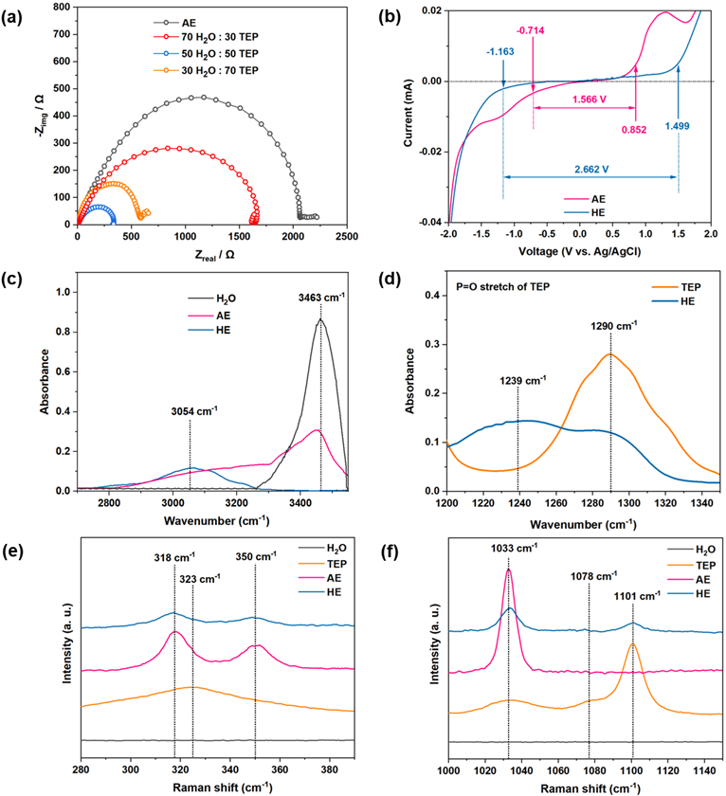
Therefore, the 50:50 H₂O:TEP mixture, which represents the optimal balance between favorable interfacial kinetics and sufficient bulk transport, was selected as the optimal solvent for the hybrid electrolyte (HE) for the subsequent investigations.
Figure 1. Electrochemical and spectroscopic characterization of electrolytes. (a) Nyquist plots of the electrolytes with varying H₂O:TEP volumetric ratios. (b) LSV curves of the AE and HE. FT-IR spectra from (c) 2700–3500 cm⁻¹ and (d) 1200–1350 cm⁻¹. Raman spectra from (e) 280–390 cm⁻¹ and (f) 1000 – 1150 cm⁻¹.

In addition to these kinetic and transport properties, the electrochemical stability was assessed using Linear Sweep Voltammetry (LSV) to complete the evaluation of the electrolytes (Figure 1b and S2). The LSV profiles reveal that the ESW systematically widens with increasing TEP content, expanding from 1.566 V in the AE to a maximum for the 70% TEP electrolyte (Figure S2). Although the 70% TEP electrolyte offers the widest ESW, the HE (50:50) provides a substantial ~70% expansion to 2.662 V (Figure 1b). This significant gain in stability, combined with the superior interfacial kinetics (lowest Rct) established, confirms that the HE composition represents the most effective overall compromise. This enhancement is attributed to the formation of a TEP-rich solvation sheath around Al-ions, which reduces the activity of free water molecules at the electrode interface [38,39].

To elucidate the molecular-level mechanisms underlying the improved ESW, the coordination environment of the electrolytes was systematically examined. In the Fourier-transform infrared (FT-IR) spectrum of the AE, a prominent and broad absorption band appears at approximately 3463 cm⁻¹, which corresponds to the O–H stretching vibrations associated with the extensive hydrogen-bonding network of bulk water (Figure 1c). In contrast, this band is significantly suppressed in the HE, indicating disruption of the hydrogen-bond network and the reduced free water content. Instead, a new broad band emerges at a lower wavenumber (~3054 cm⁻¹), attributed to water molecules strongly coordinated to Al³⁺ in the TEP dominant solvation sheath [24, 31]. The marked redshift and broadening of this bound water peak relative to that of bulk water confirms a strengthened Al³⁺–H₂O interaction, confirming a restructured solvation environment dominated by TEP coordination.

Figure 1d provides the complementary spectral evidence of the coordination between Al-ions and TEP in the HE. Bare TEP displays a characteristic band at 1290 cm⁻¹, assigned to the non-coordinating phosphoryl group [40-42]. Upon the complexation in the HE, this peak shifts significantly to 1239 cm⁻¹ and exhibits notable broadening with reduced intensity. This redshift is indicative of strong coordination between the phosphoryl oxygen and Al³⁺, which weakens the P=O bond and results in a broader distribution of vibrational environments. The declined peak intensity further supports the conversion of free TEP molecules into Al³⁺-bound species in the solvation sheath.

To further clarify the coordination environment of Al-ions in the HE, Raman spectroscopy was conducted (Figure 1e and f). In the low-frequency range (Figure 1e), the AE exhibits two distinct features; a sharp peak at ~ 318 cm⁻¹ and a broader band at ~ 350 cm⁻¹. 318 cm⁻¹ peak is associated with Al–O interactions involving either coordinated water or triflate anions [43-45], while the latter is indicative of Al–O stretching from [Al(H₂O)₆]³⁺ complexes [43, 46, 47]. The HE spectrum shows a broad shoulder spanning 315–325 cm⁻¹, which is also observed in neat TEP. This feature is therefore attributed to P–O–C bending modes within the phosphate structure [48-51]. Although a comparable band appears in the AE spectrum, it is narrower and more intense, consistent with a well-defined Al–O coordination environment involving water. In contrast, the broader and less defined feature observed in the HE reflects the involvement of TEP in Al³⁺ coordination, suggesting that TEP progressively replaces water and triflate anions.

The high-frequency region Raman spectra, shown in Figure 1f, offer further insight into the solvation structure. Pristine TEP exhibits bands at 1033 and 1101 cm⁻¹, corresponding to P–O–C and P=O stretching vibrations, respectively [48, 52]. A shoulder band present near 1080 cm⁻¹ originates from the combined band or overtone associated with P=O moiety [52]. Due to the overlapping contributions from the symmetric SO₃ stretching mode of (Otf)⁻, the intensity of 1033 cm⁻¹ peak increases in the AE and the HE [53]. The 1101 cm⁻¹ band remains weak in the AE, whereas it broadens in the HE. This broadening originates from the perturbation of the local P=O bonding due to the coordination between the phosphoryl oxygen of TEP and Al³⁺ [54]. Overall, the spectroscopic evidence confirms the formation of a distinct solvation structure in the HE, in which TEP plays a pivotal role. This reconfiguration of the Al³⁺ coordination environment underpins the improved electrochemical stability in the HE.

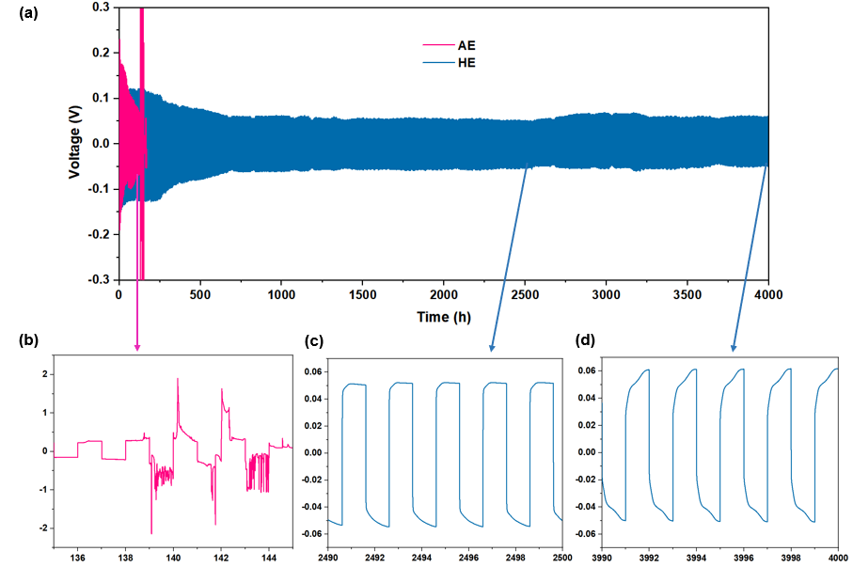
To investigate how reconfigured solvation environment practically translates into improved interfacial stability, the reversibility of plating/stripping was investigated using symmetric cells assembled with Al or Al-Zn electrodes in the AE at 0.2 mA cm⁻² and 0.2 mAh cm⁻² (Figure S3). The Al || Al cell displays a large initial overpotential, ca. 1.3 V, which gradually increases with cycling and leads to pronounced voltage instability beyond 130 h. This behavior is attributed to the accumulation of a native Al₂O₃ layer on the metallic Al surface, which hinders uniform Al deposition and dissolution. Even in the HE, the rapid failure of Al symmetric cells underscores the fundamental limitation of the inherently passivated Al metal anode (Figure S4).
Figure 2. Electrochemical performance of Al-Zn symmetric cells (a) Long-term voltage profile. Enlarged voltage profiles from (b) 135-145 hours of AE; (c) 2490-2500 hours; and (d) 3990-4000 hours in HE at 0.2 mA cm⁻² and 0.2 mAh cm⁻².

Conversely, the Al-Zn symmetric cell shows markedly lower and more stable overpotentials of ~ ± 0.2 V during early cycling period. This improvement is due to the formation of Al-Zn alloys, which facilitate nucleation of Al-ions by circumventing the insulating oxide layer [22-24]. The alloying interface provides a more favorable energetic landscape for charge transfer, enabling smoother plating/stripping during the initial operation. Despite the improved kinetics, the cycle life remains constrained in the AE; severe polarization leads to cell failure after ~ 130 h, suggesting progressive interfacial degradation.

Al-Zn symmetric cell in the HE upon the addition of TEP exhibits durable cycling stability, in stark contrast to the swift degradation observed in the AE (Figure 2 a and b). The cell sustains highly reversible deposition of Al for over 4000 hours with a markedly low and stable voltage hysteresis. The overpotential shows only a marginal increase of ~ 10 mV from 2500 hours (Figure 2c) to 4000 hours (Figure 2d), highlighting the favorable charge transfer with stabilized electrode-electrolyte interface. To further probe the interfacial stability of the system, the rate capability was evaluated at current densities ranging from 0.2 to 3.2 mA cm⁻² (Figure S5). The voltage hysteresis remained remarkably stable, showing only a modest increase at higher rates. This behavior is indicative of robust interfacial kinetics and the structural resilience of the Al-Zn electrode within the HE.
A detailed post-mortem analysis was therefore conducted to characterize the morphology and composition of the anode interface responsible for the enhanced plating/stripping performance (Figure 3). The optical images of the cycled Al–Zn electrodes in Figure S6 visually contrast the deposition uniformity between the AE and HE systems after 10 plating/stripping cycles. While the AE-cycled electrode displays an uneven, patchy surface coverage, the HE-cycled electrode exhibits a smooth and homogeneously coated surface. To further investigate the surface morphology, scanning electron microscopy (SEM) was performed (Figure 3a and b).

In the AE (Figure 3a), the anode surface consists of coarse, nodular deposits interspersed with pervasive microcracks. Such features are consistent with non-uniform local current density and parasitic side reactions, such as HER, that disrupt ion flux during the early cycles, producing a mechanically fragile and poorly adherent alloy layer. By contrast, the surface after cycling in the HE (Figure 3b) appears compact and terraced, lacking the porous nodules and crack network. This ordered, plate-like morphology is consistent with more uniform interfacial current distribution, yielding a cohesive deposit that induces enhanced surface integrity of Al-Zn anode in the HE.

Cross-section image of an electrode cycled in the HE from high resolution field-emission SEM (HR FE-SEM) (Figure 3c) reveals a uniform and compact Al-Zn deposition layer with a clearly defined interface against the underlying Zn substrate. Elemental mapping by energy-dispersive X-ray spectroscopy (EDS) further verifies the formation of an Al–Zn alloy layer (Figure 3d), with aluminum uniformly distributed along the electrode surface (Figure 3e).

X-ray photoelectron spectroscopy (XPS) was conducted on Al–Zn electrodes after cycling to examine the surface chemical states (Figure 3f and g). The Al 2p spectrum for both samples shows a primary peak at ~74.5 eV, corresponding to oxidized Al³⁺ species [55,56]. However, a detailed analysis of the peak shape reveals critical differences. The Al 2p peak for the electrode cycled in the HE exhibits a more pronounced asymmetry with a broader shoulder at a lower binding energy, suggesting a significant contribution from an Al-Zn alloyed state alongside the oxide [57]. In contrast, the peak from the AE sample is more symmetric, closely resembling that of a standard passivating aluminum oxide layer [22-24].

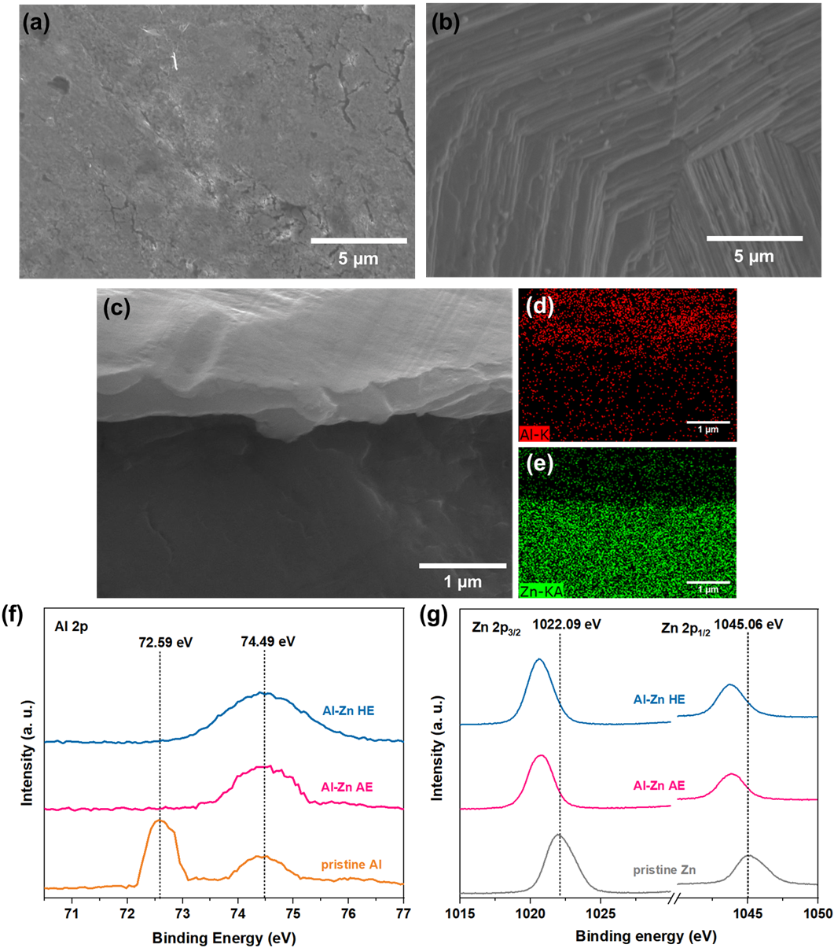
This observation is complemented by the Zn 2p spectra (Figure 3g). Both cycled electrodes exhibit the characteristic Zn 2p₃/₂ and Zn 2p₁/₂ doublets shifted to lower binding energies compared to pristine Zn, confirming Al-Zn alloy formation [58, 59]. Notably, this downshift is subtly more significant in the HE, indicating a more intimate and uniform electronic interaction between Al and Zn atoms. Taken together, these detailed XPS features—the asymmetric Al 2p peak and more pronounced Zn 2p shift in the electrode cycled in the HE—provide strong evidence for the formation of a more robust and electronically distinct Al-Zn alloy interface. This well-formed alloy interface is critical, as it acts as a stable, conductive pathway, effectively preventing the formation of a passivating, electrically-insulating Al₂O₃ layer. This interfacial stabilization is the direct cause of the dramatically improved cycling stability and lower overpotentials observed for the HE system.
Figure 3. Structural analysis of electrodes after 10 cycles at 0.2 mA cm⁻² and 0.2 mAh cm⁻². SEM images for Al-Zn cycled in (a) AE and (b) HE. (c) Cross-section HR FE-SEM image for Al-Zn cycled in HE with EDS mapping of (d) Al and (e) Zn. XPS spectra of (f) Al 2p and (g) Zn2p.

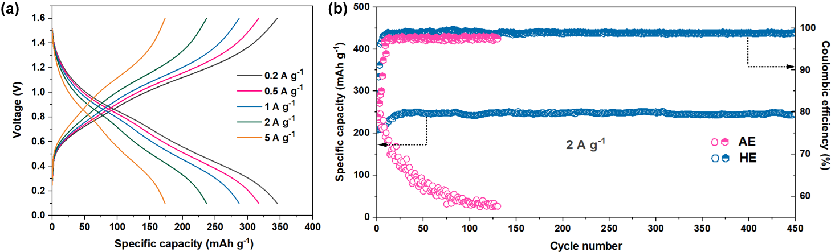
X-ray diffraction (XRD) analysis was conducted to further confirm the formation of Al-Zn alloy after electrochemical cycling (Figure S7). The diffraction pattern of pristine Zn displays two characteristic peaks centered at 36.51° and 39.31°, corresponding to the (002) and (100) planes of hexagonal Zn. In comparison, both peaks of Al-Zn in the AE and HE exhibit a slight shift toward lower 2θ values, indicative of lattice expansion induced by Al incorporation [60]. The absence of metallic Al or Al₂O₃ diffraction (i.e., 2θ of 38.47° for (111), 44.74° for (200), 65.13° for (220), 78.13° for (311) for Al (FCC) or broad peaks for γ-Al₂O₃) features suggest that Al is fully incorporated into the Zn lattice without forming separate crystalline Al or oxide phases. This lattice distortion, consistent with the XPS results, further supports the deposition via Al-Zn alloying.
Figure 4 demonstrates the electrochemical performance of the V₂O₅/C || Al-Zn full cell. The galvanostatic charge-discharge (GCD) profile at various current densities in the HE (Figure 4a) confirms its robust charge transfer kinetics. The cell delivered high reversible capacities of 378, 337, 295, 248, and 182 mAh g⁻¹ at 0.2, 0.5, 1, 2, and 5 A g⁻¹, respectively, showcasing excellent rate capability. Even at a high current of 5 A g⁻¹, a well-defined voltage profile was retained, indicating stable and fast charge transfer within the unique solvation structure of the HE.
Figure 4. Electrochemical performance of V₂O₅/C || Al-Zn. (a) GCD curves with varying current densities in HE. (b) Long-term cycling performance in AE and HE at 2 A g⁻¹.

A comparative long-term cycling performance was evaluated at 2 A g⁻¹ to assess the enhanced interfacial stability by the HE. The AE cell exhibited rapid capacity fade, retaining < 10% of its initial capacity after 130 cycles; whereas the HE cell maintained >96% of its post-formation capacity over 450 cycles with the average coulombic efficiency of 98.8%. Furthermore, post-mortem analysis confirmed that the Al-Zn anode maintained its structural integrity after 400 cycles, exhibiting a dense morphology without a sign of dendritic growth (Figure S8). Taken together, these results indicate that the TEP-modified hybrid electrolyte enhances interfacial stability at the Al–Zn alloy anode and mitigates surface degradation during extended cycling.

4. Conclusions

In summary, our findings demonstrate that the rational coordination environment design via TEP significantly reshapes Al³⁺ solvation, mitigates parasitic reactions, and stabilizes interfacial alloy formation. This approach not only resolves long-standing instability issues in aqueous Al batteries, but also enables their integration into practical full cells with superior cycle life. The strategy opens avenues for electrolyte-driven stabilization in other multivalent-ion systems, offering a scalable path toward safe and sustainable energy storage.

Supplementary Materials: The following supporting information can be downloaded at: https://www.mdpi.com/article/doi/s1, Figure S1. Ionic conductivity (black) and viscosity (red) of the electrolytes with varying TEP composition; Figure S2. LSV curves of the electrolytes with varying TEP composition over (a) -2.0 – 2.0 V; (b) -2.0 to 0.5 V; and (c) 0.5 – 2.0 V; Figure S3. Plating/stripping performance of Al || AE || Al and (b) Al-Zn || AE || Al-Zn; Figure S4. Plating/stripping performance of Al || HE || Al; Figure S5. Voltage profile of Al-Zn || HE || Al-Zn at varying current densities; Figure S6. Optical image of Al-Zn electrodes after 10 cycles in (a) AE and (b) HE; Figure S7. XRD pattern of pristine Zn and Al-Zn; Figure S8. SEM image for Al-Zn after 400 cycles in V₂O₅/C || HE || Al-Zn.
Author Contributions: K.-I. K.: conceptualization, methodology, writing and editing.
Data Availability Statement: The data presented in this study are available upon request from the corresponding author to ensure integrity and prevent misunderstanding or misuse.
Acknowledgments: This work was supported by the Gachon University research fund of 2023 (GCU-202400930001), the National Research Foundation of Korea (NRF) grant funded by the Korean government (MSIT) (RS-2024-00429941) and the Korean Institute for Advancement of Technology (KIAT) grant funded by the Korean government (MOTIE) (RS-2025-02305000, HRD Program for Industrial Innovation).
Conflicts of Interest: The author declares no conflicts of interest.

References
[1] K.-i. Kim, J. Electrochem. Sci. Technol., 2025, 16(1), 37-53.
[2] D. Chao, W. Zhou, F. Xie, C. Ye, H. Li, M. Jaroniec and S. Z. Qiao, Sci. Adv., 2020, 6(21), eaba4098.
[3] L. E. Blanc, D. Kundu and L. F. Nazar, Joule, 2020, 4(4), 771-799.
[4] H. Jia, Z. Wang, B. Tawiah, Y. Wang, C. Y. Chan, B. Fei and F. Pan, Nano Energy, 2020, 70, 104523.
[5] Y. Ru, S. Zheng, H. Xue and H. Pang, Chem. Eng. J., 2020, 382, 122853.
[6] L. Butterwick and G. D. W. Smith, Resour. Conserv. Recycl., 1986, 9(3), 281-292.
[7] D. J. Kim, D.-J. Yoo, M. T. Otley, A. Prokofjevs, C. Pezzato, M. Owczarek, S. J. Lee, J. W. Choi and J. F. Stoddart, Nat. Energy, 2019, 4, 51-59.
[8] Z. J. Lin, M. L. Mao, C. X. Yang, Y. X. Tong, Q. H. Li, J. M. Yue, G. J. Yang, Q. H. Zhang, L. Hong, X. Q. Yu, L. Gu, Y. S. Hu, H. Li, X. J. Huang, L. M. Suo and L. Q. Chen, Sci. Adv., 2021, 7, eabg6314.
[9] Q. Pang, J. Meng, S. Gupta, X. Hong, C. Y. Kwok, J. Zhao, Y. Jin, L. Xu, O. Karahan, Z. Wang, S. Toll, L. Mai, L. F. Nazar, M. Balasubramanian, B. Narayanan and D. R. Sadoway, Nature, 2022, 608, 704-711.
[10] Y. Guo, W. Wang, H. Lei, M. Wang and S. Jiao, Adv. Mater., 2022, 34, 2110109.
[11] X. Ji, Energy Environ. Sci., 2019, 12(11), 3203-3224.
[12] Y. Chen, Y. Kang, Y. Zhao, L. Wang, J. Liu, Y. Li, Z. Liang, X. He, X. Li, N. Tavajohi and B. Li, J. Energy Chem., 2021, 59, 83-99.
[13] K. Chayambuka, G. Mulder, D. L. Danilov and P. H. Notten, Adv. Energy Mater., 2020, 10(38), 2001310.
[14] Q. Wang, B. Mao, S. I. Stoliarov and J. Sun, PROG. ENERG. COMBUST., 2019, 73, 95-131.
[15] M. Angell, C. Y. Lin, Y. J. Chang, C. T. Chen, C. C. Lin, Y. T. Chen, C. W. Wang, H. Dai and C. C. Chang, Proc. Natl. Acad. Sci. U.S.A., 2017, 114(5), 834–839.
[16] M. Chiku, M. Matsumoto, T. A. Yamamoto, Y. Nagaoka, K. Takechi and Y. Kubo, J. Electrochem. Soc., 2015, 162(11), A1742–A1746.
[17] M. Zhao, Y. Huang, L. Peng, Z. Liu, Y. Liu, S. Wang and G. Yu, Proc. Natl. Acad. Sci. U.S.A., 2018, 115(2), 285–290.
[18] G. R. Pastel, Y. Chen, T. P. Pollard, M. A. Schroeder, M. E. Bowden, A. Zheng, N. T. Hahn, L. Ma, V. Murugesan, J. Ho, M. Garaga, O. Borodin and K. Xu, Energy Environ. Sci., 2022, 15(6), 2460-2469.
[19] T. Dong, K. L. Ng, Y. Wang, O. Voznyy and G. Azimi, Adv. Energy Mater., 2021, 11(20), 2100077.
[20] Z. Zhao, Z. Zhang, T. Xu, W. Wang, B. Wang and X. Yu, J. Am. Chem. Soc., 2024, 146(3), 2257-2266.
[21] M. Trachtman, G. D. Markham, J. P. Glusker, P. George and C. W. Bock, Inorg. Chem., 1998, 37(17), 4421-4431.
[22] C. Yan, C. Lv, L. Wang, W. Cui, L. Zhang, K. N. Dinh, H. Tan, C. Wu, T. Wu, Y. Ren, J. Chen, Z. Liu, M. Srinivasan, X. Rui, Q. Yan and G. Yu, J. Am. Chem. Soc., 2024, 142(36), 15295-15304.
[23] X. Yang, C. Zhang, L. Chai, W. Zhang and Z. Li, Adv. Mater., 2022, 34(45), 2206099.
[24] Q. Dou, N. Yao, W. K. Pang, Y. Park, P. Xiong, X. Han, H. H. Rana, X. Chen, Z.-H. Fu, L. Thomsen, B. Cowie, Y. Kang, Q. Liu, D. H. Min, Y. M. Jung, Z. Guo, Q. Zhang and H. S. Park, Energy Environ. Sci., 2022, 15(11), 4572-4583.
[25] Q. Ran, H. Shi, H. Meng, S.-P. Zeng, W.-B. Wan, W. Zhang, X.-Y. Lang and Q. Jiang, Nat. Commun., 2022, 13(1), 576.
[26] B. E. Jia, E. Hu, Z. Hu, J. J. Liew, Z. Hong, Y. Guo, M. Srinviassan, Q. Zhu, J. Xu, J. Chen, H. Pan and Q. Yan, Energy Storage Mater., 2024, 65, 103141.
[27] X. Wang, C. Zhao, P. Luo, Y. Xin, Y. Ge and H. Tian, Nanoscale, 2024, 16(27), 13171-13182.
[28] J. Chen, J. Vatamanu, L. Xing, O. Borodin, H. Chen, X. Guan, X. Liu, K. Xu and W. Li. Adv. Energy Mater., 2020, 10(3), 1902654.
[29] J. Shi, K. Xia, L. Liu, C. Liu, Q. Zhang, L. Li, X. Zhou, J. Liang and Z. Tao. Electrochim. Acta, 2020, 358, 136937.
[30] D. Yang, M. Watanabe, A. Takagaki and T. Ishihara, J. Electrochem. Soc., 2022, 169(12), 120516.
[31] Q. Dou, S. Lei, D.-W. Wang, Q. Zhang, D. Xiao, H. Guo, A. Wang, H. Yang, Y. Li, S. Shi and X. Yan, Energy Environ. Sci., 2018, 11(11), 3212-3219.
[32] F. Wang, O. Borodin, M. S. Ding, M. Gobet, J. Vatamanu, X. Fan, T. Gao, N. Eidson, Y. Liang, W. Sun, S. Greenbaum, K. Xu and C. Wang, Joule, 2018, 2(5), 927-937.
[33] L. Miao, R. Wang, S. Di, Z. Qian, L. Zhang, W. Xin, M. Liu, Z. Zhu, S. Chu, Y. Du and N. Zhang, ACS nano, 2022, 16(6), 9667-9678.
[34] B. Kakoty, R. Vengarathody, S. Mukherji, V. Ahuja, A. Joseph, C. Narayana, S. Balasubramanian and P. Senguttuvan, J. Mater. Chem. A., 2022, 10(23), 12597-12607.
[35] H. Ren, S. Li, L. Xu, L. Wang, X. Liu, L. Wang, Y. Liu, L. Zhang, H. Zhang, Y. Gong, C. Lv, D. Chen, J. Wang, Q. Lv, Y. Li, H. Liu, D. Wang, T. Cheng, B. Wang, D. Chao and S. Dou, Angew. Chem., 2025, 137(13), e202423302.
[36] H. Jia, X. Jiang, Y. Wang, Y. Lam, S. Shi, G. Liu, Adv. Energy Mater., 2024, 14(18), 2304285.
[37] L. C. Greenburg, J. Holoubek, Y. Cui, P. Zhang, H. Ai, E. Zhang, C. Liu, G. Feng and Y. Cui, ACS Energy Lett., 2025, 10, 1022-1029.
[38] F. Wang, O. Borodin, T. Gao, X. Fan, W. Sun, F. Han, A. Faraone, J. A. Dura, K. Xu and C. Wang. Nat. Mater., 2018, 17(6), 543-549.
[39] A. Naveed, H. Yang, J. Yang, Y. Nuli, and J. Wang, Angew. Chem., Int. Ed., 2019, 58(9), 2760-2764.
[40] A. F. Ali, P. Mustarelli and A. Magistris, Mater. Res. Bull., 1998, 33(5), 697-710.
[41] A. Rulmont, R. Cahay, M. L.-Duyckaerts, and P. Tarte, Eur. J. Solid State Inorg. Chem., 1991, 28(1), 207-219.
[42] D. J. Kim, H. Y. Hwang, and S. Y. Nam, Macromol. Res.Up, 2013, 21(11), 1194-1200.
[43] W. W. Rudolph, R. Mason and C. C. Pye, Phys. Chem. Chem. Phys., 2000, 2(22), 5030-5040.
[44] W. W. Rudolph and G. Irmer, Dalton Trans., 2015, 44(1), 295-305.
[45] S. Kumar, P. Rama, G. Yang, W. Y. Lieu, D. Chinnadurai and Z. W. Seh, Nanomicro Lett., 2023, 15(1), 21.
[46] P. Latos, A. Culkin, N. Barteczko, S. Boncel, S. Jurczyk, L. C. Brown, P. Nockemann, A. Chrobok and M. Swadźba-Kwaśny, Front. Chem., 2018, 6, 535.
[47] A. Ejigu, L. W. Le Fevre, A. Elgendy, B. F. Spencer, C. Bawn and R. A. Dryfe, ACS Appl. Mater. Interfaces., 2022, 14(22), 25232-25245.
[48] K. Czamara, K. Majzner, M. Z. Pacia, K. Kochan, A. Kaczor and E. M. Baranska, J. Raman Spectrosc., 2015, 46(1), 4-20.
[49] K. M. Ta, D. J. Cooke, L. J. Gillie, S. C. Parker, S. Seal, P. B. Wilson, R. M. Phillips, J. M. Skelton and M. Molinari, J. Phys. Chem. C., 2023, 127(40), 20183-20193.
[50] M. Latreche, J. F. Willart, L. Paccou, Y. Guinet, F. Danède and A. Hédoux, Eur. J. Pharm. Biopharm., 2020, 154, 222-227.
[51] K. I. Hadjiivanov, D. A. Panayotov, M. Y. Mihaylov, E. Z. Ivanova, K. K. Chakarova, S. M. Andonova and N. L. Drenchev, Chem. Rev., 2020, 121(3), 1286-1424.
[52] B. S. Fales, N. O. Fujamade, Y. W. Nei, J. Oomens and M. T. Rodgers, J. Am. Soc. Mass Spectrom., 2011, 22(1), 81-92.
[53] A. Horvath, R. S. Anaredy and S. K. Shaw, Langmuir, 2022, 38(30), 9372-9381.
[54] R. Murugavel, A. Choudhury, M. G. Walawalkar, R. Pothiraja and C. N. R. Rao, Chem. Rev., 2008, 108(9), 3549-3655.
[55] S. Feliu Jr. and V. X. P. S. Barranco, Acta Mater., 2003, 51(18), 5413-5424.
[56] L. Bonova, A. Zahoranová, D. Kováčik, M. Zahoran, M. Mičušík and M. Černák, Appl. Surf. Sci., 2015, 331, 79-86.
[57] A. Han, J. Zhang, W. Sun, W. Chen, S. Zhang, Y. Han, Q. Feng, L. Zheng, L. Gu, C. Chen, Q. Peng, D. Wang and Y. Li, Nat. Commun., 2019, 10(1), 3787.
[58] Y. Xu, X. Cui, S. Wei, Q. Zhang, L. Gu, F. Meng, J. Fan and W. Zheng, Nano Res., 2019, 12(5), 1173-1179.
[59] M. Gong, Z. Deng, D. Xiao, L. Han, T. hao, Y. Lu, T. Shen, X. Liu, R. Lin, T. Huang, G. Zhou, H. Xin and D. Wang, Acs Catal., 2019, 9(5), 4488-4494.
[60] C. Yang, Z. Wu, G. Zhang, H. Sheng, J. Tian, Z. Duan, H. Sohn, A. J. Kropf, T. Wu, T. R. Krause and J. T. Miller, Catal. Today., 2019, 323, 123-128.

