Type of the Paper (Review)
Recent Advances in Metal-Organic Frameworks & Coordination Polymers for Electrochemical Biosensors in Both In Vivo & In Vitro Sensing
Alemayehu Kidanemariam ¹ and Sungbo Cho ^{2*}
Citation: To be added by editorial staff during production.
Academic Editor: First name Lastname
Received: date
Revised: date
Accepted: date
Published: date

Copyright: © 2024 by the authors. Submitted for possible open access publication under the terms and conditions of the Creative Commons Attribution (CC BY) license (https://creativecommons.org/licenses/by/4.0/).
¹ Department of Electronic Engineering, Gachon University, Seongnam-si 13120, Republic of Korea.
² Department of Electronic Engineering, Gachon University, Seongnam-si 13120, Republic of Korea.
* Correspondence: sbcho@gachon.ac.kr;
Abstract: Electrochemical biosensors are critical in advancing biomedical and pharmaceutical therapies because of their adaptability and cost-effectiveness. Voltammetric and amperometric sensors are of particular interest. These sensors typically consist of a specialized tip or biorecognition element and a transducer that converts biological data into readable signals. Efficient biosensor materials are essential for addressing health emergencies, with coordination polymers (CPs) and metal-organic frameworks (MOFs) showing promise. Functionalization strategies are necessary to enhance the usability of pristine MOFs, owing to issues such as low conductivity. The integration of conductive polymers with MOFs has resulted in the development of highly efficient biosensors. Both enzymatic and nonenzymatic biosensors are used for analyte detection; nonenzymatic approaches are gaining popularity owing to their durability and accuracy. MOFs and CPs have been applied in sensitive electrochemical biosensors to detect fatal brain tumors such as glioblastomas (GBM). These biosensors demonstrate enhanced selectivity and sensitivity, highlighting the potential of MOFs and CPs in advancing electrochemical biosensor technology for both in vivo and in vitro applications.
Keywords: Coordination chemistry; bioMOFs; coordination polymers; composite materials; electrochemical applications; biosensors; in vivo & in vitro biosensing

Graphical abstract

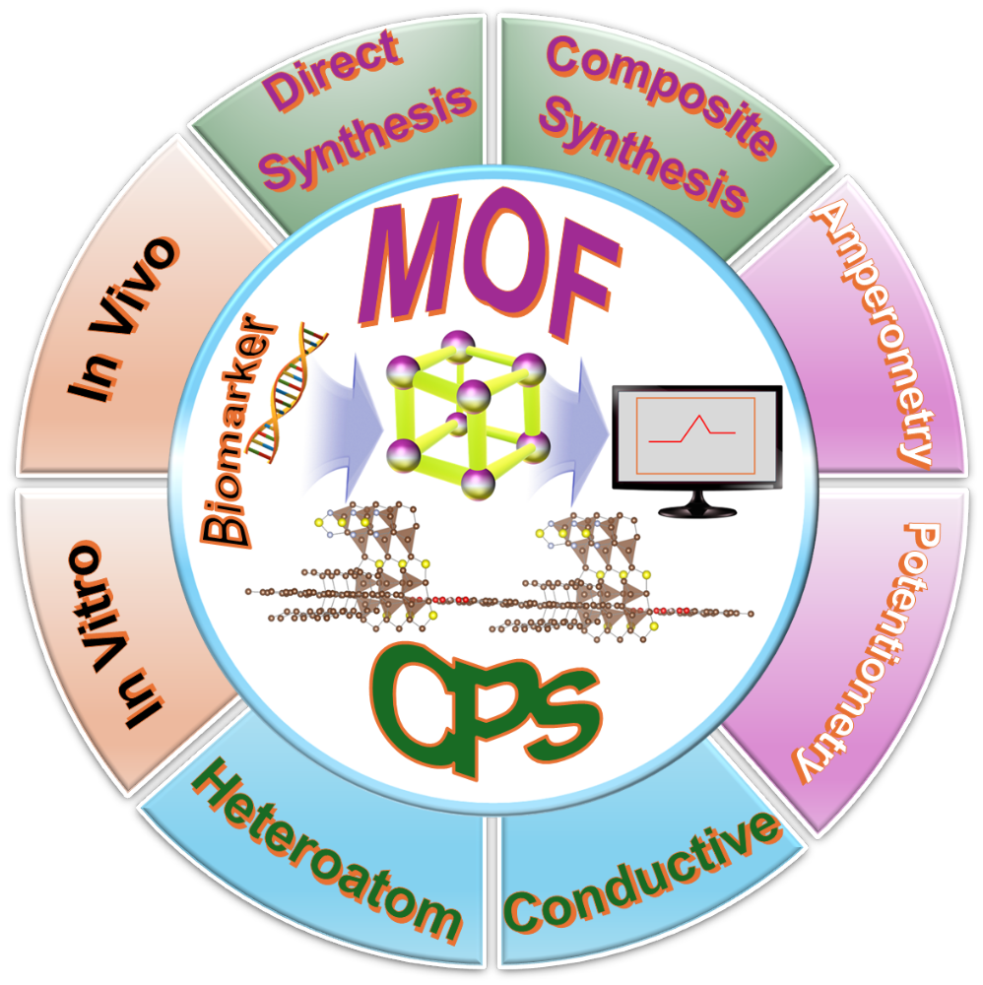

Abbreviations
- PEC – photoelectrochemical
- EC – electrochemical
- ECL – electrochemiluminescent
- FRET – fluorescence resonance-based energy transfer
- PSM - post-synthetic modification
- BET – Brunauer-Emmett-Teller
- CV – cyclic voltammetry
- SWV – square-wave voltammetry
- GCE – glass carbon electrode
- SPE – screen printed electrode
- MOFs – metal-organic frameworks
- CPs – coordination polymers
- GO – graphene oxide
- PANI – polyaniline
- GBM – glioblastoma
- BDC – benzene dicarboxylic acid
- UiO-66 – Universitetet i Oslo
- MIL-91(Ti) – Materials of Institute Lavoisier-91 Titanium
- MOF-177 – Materials of Institute Lavoisier-177
- ZIF-8 – Zeolitic Imidazolate Framework-8
- BTB – 4,4′,4”-benzene-1,3,5-triyl-tris(benzoate)
- NDC – 2,6-naphthalene dicarboxylate
- PQDs – perovskite quantum dots
- HHTP – 2,3,6,7,10,11-hexahydroxytriphenylene
- EDTA – ethylenediaminetetraacetic acid
- PAN – polyacrylonitrile
- H₄tptc – p-terphenyl-2,2′′,5′′,5′′′-tetracarboxylic acid
- phen – 1,10-phenanthroline
- Ru-PEI-L-lys – ru(dcbpy)32+-polyethyleneimine-L-lysine
- DCN – 2,6-dichloro-4-nitroaniline
- p-NP – p-nitrophenol
- PAni – polyaniline
- PPy – polypyrrole
- PEDOT – poly(3,4-ethylene dioxythiophene)
- PEDOT:PSS – (3,4-ethylene dioxythiophene)-poly(styrene sulfonate)
- MB – methylene blue
- PBS – phosphate-buffered saline
- ATP – adenosine triphosphate
- NPs – nanoparticles
- SWNH – single-walled nanotube
- MWCNTs – multiwalled carbon nanotubes
- LOW – low detection limit
- MVL ATRP – metal-free visible-light-induced atom transfer radical polymerization
- MBA – 4-mercaptobenzoic acid
- CTCs – circulating tumor cells

1. Introduction
Electrochemical biosensor materials are crucial for the advancement of biomedicine and pharmaceutical therapies [1]. Electrochemical biosensors are broadly accepted owing to their adaptability and low cost compared to traditional techniques such as atomic emission spectroscopy (AES), chromatography, and inductively coupled plasma mass spectroscopy (ICP-MS) [2]. Electrochemical sensors can be classified into five types: conductive, potentiometric, impedimetric, amperometric, and voltammetric [3,4]. Of the five classes of electrochemical sensors, voltammetric and amperometric sensors are considered acceptable [5]. The typical structure of a biosensor comprises a specialized tip or biorecognition element sensitive to a particular analyte along with a transducer [6]. This biorecognition element, selected from a range of molecules such as enzymes, antibodies, nucleic acids, carbohydrates, and cellular structures, interacts with specific analytes, leading to biological or chemical alterations [7]. The transducer then uses data from the biological element and converts them into colorimetric, electrical, or other readable signals [8]. An efficient biosensor material can readily handle health-based emergency scenarios in which the speed of response makes a real difference. Therefore, the synergy of a biosensor material plays an important role in the effectiveness of its practical applications. Researchers have been investigating the development of efficient biosensor materials for practical clinical use [9–11]. Various organic and inorganic materials have been studied for their potential applications in biosensing [12,13]. Recently, different materials such as macromolecules, polymers, nanoparticles, and hydrogels have been recognized for their practical application in the field of biosensing [14,15]. Coordination polymers (CPs) and metal-organic frameworks (MOFs) have been studied for use in biomedicine.
MOFs are crystalline porous coordination polymers constructed from metal ion-based nodes and organic linkers [16]. The inherent versatility of these polymers, such as tailorable pore size, high surface-area-to-volume ratio, and ample active sites, make MOFs candidates for various applications, such as sensors, energy storage, catalysis, and drug delivery [17,18]. MOFs are optimal candidates for electrochemical biosensor applications because of their inherent structural and chemical compositions [19,20]. Their exceptional porosity and specific surface area facilitate enhanced analyte mass transfer, resulting in moderate electric signal amplification and increased detection sensitivity [21]. Moreover, the tunable pore dimensions within MOFs contribute to enhanced selectivity by enabling size-based screening and exclusion of targeted analytes [22]. In addition, the abundance of unsaturated metal sites in MOFs provides opportunities for versatile functionalization with various materials, thereby broadening their applicability. Through deliberate functionalization and precise construction, MOFs can be tailored to develop highly efficient biosensors with enhanced selectivity and sensing capabilities across a wide spectrum of analyte concentrations [23]. Pristine MOFs are usually susceptible to low conductivity and poor chemical and humidity resilience, which hinder the practical application of these materials for electrochemical biosensors; therefore, the identification of an appropriate route for the functionalization of these MOFs could revolutionize the electrochemical sensor field [24]. This strategic approach holds promise for the development of robust biocompatible electrochemical biosensors capable of detecting diverse small biotic and abiotic molecules, including H₂O₂, glucose, and heavy metals [25].
Furthermore, CPs have found widespread applications in both electrochemical and biomedical fields [26]. These CPs, comprising metal elements and organic ligands, offer versatility in composite formation with diverse materials, leading to enhanced electrochemical biosensing capabilities of the final product [27]. Various CPs have been investigated for use in gas separation, catalysis, and drug delivery. Presently, there is a growing interest in exploring CPs for electrochemical biosensors, particularly through their integration with other inorganic and organic substances, showing promising potential for both in vivo and in vitro biosensing applications [28]. Typically, in the development of biocompatible and redox-active CP-based biosensors, biological ligands such as amino acids are complexed with transition metals [29]. Furthermore, CPs have been investigated for their ability to significantly enhance electrochemical biosensing activities by incorporating lanthanide ions as coordination centers and leveraging their unique optical nature, high coordination number, and electronic and photoluminescence properties [30]. To develop effective electrochemical biosensors, nanoscale materials, including noble metals, oxides, carbon, and composites, have been extensively explored as substrate supports.
Cutting-edge research has recently focused on enhancing electrochemical biosensor materials through strategic integration of conductive polymers with MOFs [31]. This innovative approach capitalizes on the inherent advantages of both materials. Owing to their exceptional electrical properties, various conducting polymers have been selected to augment the electrical sensitivity of MOFs, thereby enhancing their performance in electrochemical sensing applications [32]. For instance, polyaniline (PANI), one of the most promising conducting polymers, holds significant promise when composited with MOFs, offering a synergistic effect conducive to the development of highly efficient electrochemical biosensors. Recently, Wang et al. reported that MOFs functionalized with PANI, specifically PANI deposited on UiO-66-NH2 surfaces, exhibited remarkable electrochemical performances for the identification of cadmium ions in an aqueous medium [33]. It is imperative to meticulously identify optimal methodologies for integrating conductive polymers and MOFs to advance cutting-edge electrochemical biosensor technology.
The two major classes of electrochemical biosensors used to detect analytes are enzymatic and non-enzymatic [34]. Although biocompatibility, specificity, and versatility are the advantages of enzymatic biosensors, their low stability, high temperature and pH sensitivity, and high cost hinder their practical application. In contrast, the non-enzymatic approach is known for its durability, versatility, wide operating range, and low cost of application, which will enable the practical application of biosensors as electrochemical sensors of different analytes [35]. Therefore, MOFs and CPs have been studied for their practical applications using enzymatic and non-enzymatic approaches. Sun et al. reported a sensitive and label-free electrochemical biosensor, Zr-MOF, for the detection of the most fatal brain tumor, glioblastoma (GBM) in practical applications [36]. Detection was performed based on the interaction of GBM-derived exosomes and Zr⁴⁺ ions on the Zr-MOF surface. Since methylene blue was incorporated into the electrode surface to generate strong electrochemical signals, the concentration of exosomes was quantified without extra amplification elements. The synergy between the electrode and analyte plays an important role in the enhanced and practical identification of GBM in human serum, with greater selectivity and sensitivity.
This review provides a thorough analysis of MOFs and CPs, focusing on their electrochemical biosensing capabilities for the detection of biomolecules such as DNA, glucose, amino acids, and uric acid. This review summarizes recent advancements in the last three years and explores the production of composite biosensors using materials such as graphene oxide (GO), carbon nanotubes (CNTs), metal oxide nanoparticles, and carbon paste electrodes (CPE). It also evaluates the electrochemical performance of these biosensors both independently and in a composite form.

2. Production and classification of MOFs and CPs
Considering the reaction parameters (such as temperature, concentration, pH, and reaction time) in MOFs and CPs is essential for achieving precise control over the properties and performance of these materials, which will enable their application in electrochemical biosensors. By altering the reaction parameters, the necessary pore size/distribution, specific surface area, phase purity, structural diversity, and functionality can be obtained, thus enabling the broad application of MOFs and CPs in catalysis, sensors, separation, gas storage, batteries, and adsorption [37]. Hence, the type of metal center plays an important role in the final morphology of MOFs or CPs. In particular, MOFs structural shapes are highly susceptible to the metal nodes; hence, distinct metal ions have different coordination numbers and geometries, such as square planar, square pyramidal, bipyramidal, octahedral, tetrahedral, and trigonal prismatic [38]. There are different synthetic strategies for developing MOFs and CPs, as shown in Figure 1. It is worth noting that depending on the final product, it is possible to make an informed decision regarding these synthesis routes. The assembly of the organic linker at the metal center must be considered in advance to meet the specific application requirements.
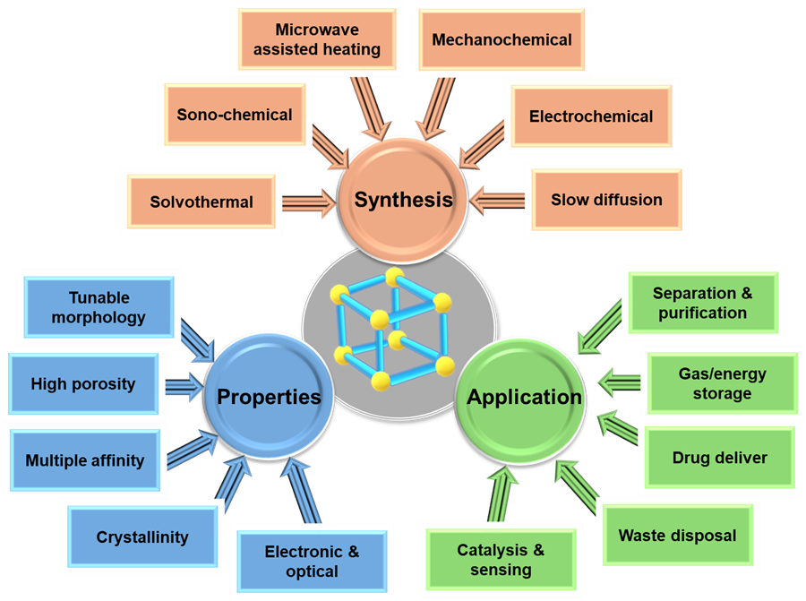
Figure 1. Synthesis properties and applications of MOFs.
2.1. Synthesis, properties, and application of MOFs and CPs
Controlling the synthesis strategy and reaction parameters of MOFs and CPs significantly affects their properties, which are crucial for their intended application [39]. Various fields require distinct physicochemical behaviors from these materials. To achieve optimal results, it is important to thoroughly understand the appropriate synthesis strategies, material properties, and desired applications.
2.1.1. Solvothermal synthesis
Solvothermal synthesis, a common technique for preparing MOF and CP, involves mixing metal ions or clusters with organic ligands in a suitable solvent and heating them under controlled conditions in a sealed vessel [40]. This method provides benefits such as precise control over the particle characteristics, enhanced crystallinity, and access to diverse MOF structures [41]. However, achieving the desired outcomes requires careful optimization of the reaction parameters, including the temperature, pressure, solvent composition, and reaction duration. Lozano et al. reported the production of UiO-66 from Zr⁴⁺ and benzene dicarboxylic acid (BDC) which was heated in an acetone solvent for 6–72 h at 40–160 ºC [42]. The solvothermal synthesis was carried out by varying the molar ratios of the metal node and organic linker, along with the reaction solvent, at various reaction times and temperatures. The results suggested that a molar ratio of 1:1:1622 of Zr: BDC:acetone at 80 ºC, for 24 h, gives better UiO-66 properties. The as-prepared UiO-66 has higher crystallinity (150 nm size crystals) and a surface area of 1299 m² g⁻¹. Therefore, the controlled production of UiO-66 provides insight into the alteration of the material properties, and the as-prepared MOF exhibits excellent CO₂ adsorption capacity. Researchers are investigating green chemistry for the fabrication of MOFs, in which water is used as a solvent. Recently, hydrothermal synthetic routes for MOFs have been investigated. MOF MIL-91(Ti) was produced by refluxing Ti⁴⁺ metal ions and N,N′-piperazine-bis (methylenephosphonic acid) in water for 68 h. The as-prepared MIL-91(Ti) exhibited a BET surface area of 360 m² g⁻¹ and a pore volume of 0.138 cm³ g⁻¹ [43].
2.1.2. Sono-chemical synthesis
The sonochemical synthesis of MOFs and CPs involves the use of ultrasound waves to aid the structural assembly [44]. In this process, metal salts and organic ligands are mixed in a solvent and exposed to ultrasonic irradiation. High-frequency ultrasound waves generate acoustic cavitation within a solution, creating localized areas of high pressure and temperature. These conditions facilitate rapid and efficient mixing of the reactants, leading to the formation and growth of MOF crystals. Sonochemical synthesis is valued for its ability to produce MOFs with controlled characteristics such as morphology, particle size, and crystallinity within a shorter timeframe than traditional methods. In addition, it offers advantages such as scalability and operability under mild reaction conditions. MOF-177 has been synthesized from Zn²⁺ and 4,4′,4′′-benzene-1,3,5-triyl-tribenzoic acid by sonochemical route under the 1-methyl-2-pyrrolidone solvent; the as-prepared material had a BET surface area of 4898 m² g⁻¹ [45]. The as-prepared MOF-177 was suitable for the adsorption of CO₂.
2.1.3. Microwave-assisted heating
Microwave-assisted MOF synthesis involves the use of microwave irradiation to accelerate chemical reactions. This method rapidly heats the reaction mixture, leading to faster synthesis than conventional heating methods. Furthermore, microwave irradiation enhances reactant diffusion, promotes the coordination between metal ions and organic ligands, and improves crystallinity, all of which contribute to the efficient formation of MOF crystals. MOF-177 was produced by microwave synthesis methods; the metal node and organic linker were mixed in a 1-methyl-2-pyrrolidone solvent and heated in the microwave for 35 min at 100 ⁰C. In addition to the faster synthesis strategy of this microwave-assisted synthesis, it results a high specific surface area of MOF-177 with 4197 m² g⁻¹ [45]. In another study, metal-organic framework and covalent organic framework composites (IRMOF₃-TzDa) were synthesized via the microwave synthesis procedure, in which Zn(NO3)2·6H2O and 2-aminoterephthalic acid were mixed in a DMF solvent and heated for 30 min (120 °C, 150 W, 5 MPa). The cube-shaped IRMOF3-TzDa exhibits fluorescence sensing and a selective Cu²⁺ ion adsorption of up to 86 mg g⁻¹; the morphology plays an important role in accommodating the heavy metal on its porous surface (Figure 2) [46]. Moreover, MOF-907 was synthesized via microwave-assisted radical polymerization within a short reaction time (30 min) [47]. As shown in Figure 2, microwave-based MOF-907 synthesis provides an opportunity for the precise control of the topology. In addition to the fast reaction, microwave-assisted MOF synthesis provides a well-structured assembly of the organic linker at the metal center.
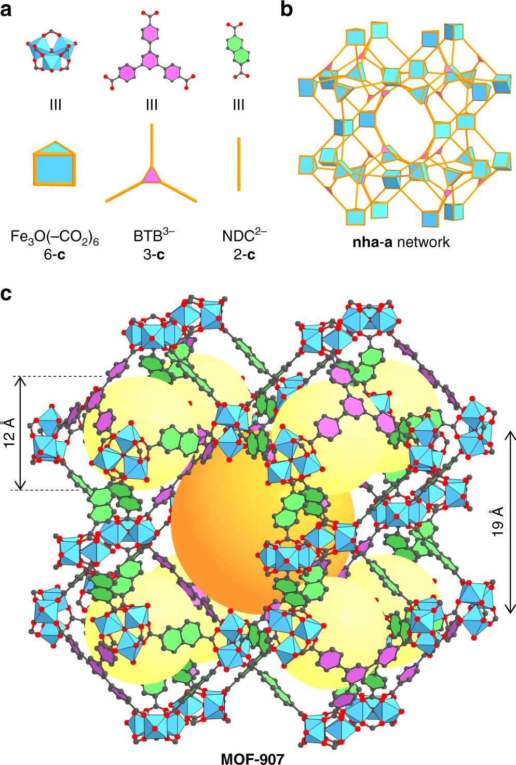
Figure 2. Structural representation of MOF-907. (a, b) Trigonal prismatic Fe₃O(–CO₂)₆ clusters linked together by triangular 4,4′,4”-benzene-1,3,5-triyl-tris(benzoate) (BTB³⁻) and linear 2,6-naphthalenedicarboxylate (NDC²⁻) linkers. Atom colors: Fe: blue polyhedra. C: black, and O: red. All H atoms are omitted for clarity. The yellow and orange spheres indicate the free space in the cages. Reproduced with permission [47]. Copyright 2018 Nature.
2.1.4. Mechanochemical synthesis
During mechanochemical MOF synthesis, solid ingredients are mixed while being ground, sometimes with a small quantity of liquid or solvent, in a ball mill or similar device [48]. The mechanical force produced during grinding helps break existing chemical bonds and aids in the creation of new bonds between metal ions and organic linkers. This approach presents numerous benefits over traditional solution-based synthesis methods, such as faster reaction times, increased yields, and the capability to generate crystalline MOFs without requiring elevated temperatures or severe reaction environments. Bhattacharyya et al. reported the solvent-free mechanochemical synthesis of a PQD@MOF composite for photovoltaic applications, which was mediated by heavy metal exchange (Figure 3). The as-prepared composite material exhibited a simple synthesis route, environmental friendliness, and efficient photovoltaic properties [48].
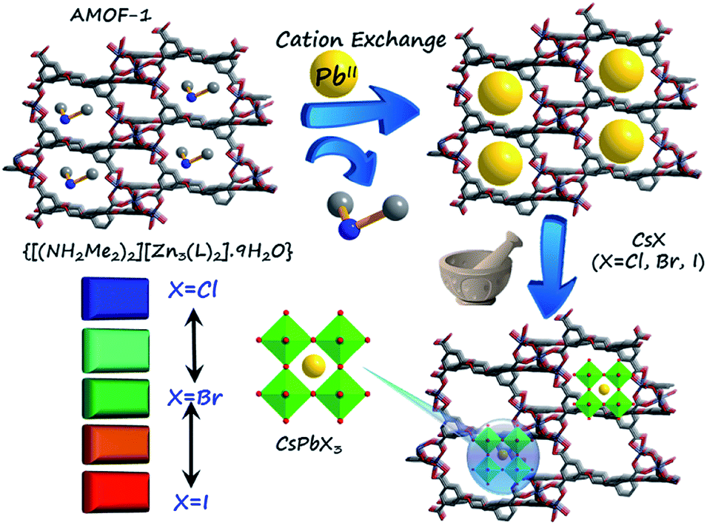
Figure 3. Mechanochemical synthesis of PQD@MOF composites mediated by Pb(II) exchanged AMOF-1. Reproduced with permission [48]. Copyright 2019 ACS.
2.1.5. Electrochemical synthesis
The electrochemical synthesis of MOFs involves the use of electrical energy to facilitate the crosslinking of organic linkers to metal nodes [49]. This method offers distinct advantages, including precise control over the reaction conditions such as potential, current, and pH. Typically, in a given electrochemical cell, MOF can be synthesized by containing metal ions and organic ligands in the solution or on the electrode. Recently, Liu et al. reported the electrochemical synthesis of 2D MOF films using a copper anode and a 2,3,6,7,10,11-hexydroxytriphenylene (HHTP) solution [50]. An organic ligand was deposited on the Cu²⁺ ions generated by the anode, as shown in Figure 4. The metal ions carried to the cathode electrode of these parameters significantly influenced the morphology, size, and composition of the resulting MOF. Additionally, this approach allows for the direct growth of MOFs on conductive substrates, facilitating the production of thin films and coatings suitable for various professional applications such as catalysis and sensing.
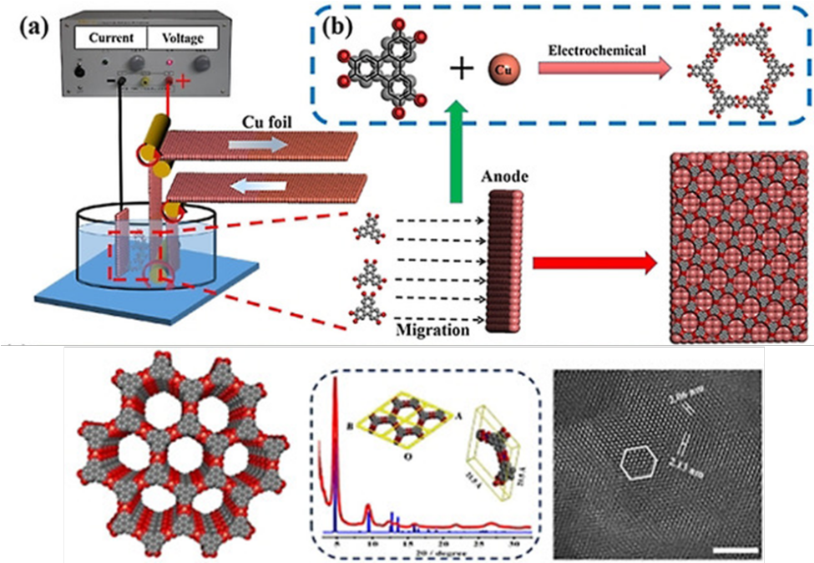
Figure 4. a) Electrochemical reaction cell for the preparation of a Cu₃(HHTP)₂ film on Cu foil. b) Schematic diagram of the coordination reaction between Cu²⁺ and the HHTP ion. Reproduced with permission [50]. Copyright 2022 Angewandte).
2.1.6. Slow diffusion
The controlled synthesis of MOFs via slow diffusion entails the gradual diffusion of reactants within a solution, thus fostering the methodological growth of MOF crystals [51]. Typically, this procedure involves the amalgamation of metal ions or clusters with organic linkers in a solvent, followed by the gradual introduction of a secondary reactant such as a modulator or solvent into the solution [52]. The deliberate diffusion of this secondary reactant facilitates the gradual nucleation and development of MOF crystals under controlled conditions, resulting in the formation of well-defined structures with tailored properties. This approach offers notable advantages, including precise control over the crystal size, morphology, and composition, making it particularly suitable for applications in catalysis and sensing.
3. Applications for the electrochemical biosensor
Recently, MOFs and CPs have been used in biocatalysis and biosensing [53]. Their structural and chemical flexibility makes MOFs particularly useful for immobilizing and preserving enzymes. One approach involves loading enzymes into MOFs after synthesis by utilizing the porous nature of MOFs. However, this method faces challenges, such as limited enzyme loading due to poor attachment or adsorption, absorption difficulties, and pore size limitations [54]. To address these issues, innovative methods have been developed, such as a the co-precipitation technique, in which the MOF forms around the enzyme in a biomimetic manner, providing enhanced protection. Moreover, the application of MOFs in practical electrochemical biosensing has been hampered by their low electrochemical stability, limited electrical conductivity, limited mass transport, low compatibility with electrode materials, low scalability, and high cost [55]. Therefore, for the application of MOFs and CPs in practical clinical biosensing and therapeutic applications, there should be a mechanism that addresses these issues. Researchers are working to improve the electrochemical performance of MOFs and CPs by employing material engineering, surface modification techniques, and synthesis process optimization to achieve the utilization of MOFs for electrochemical biosensing applications [56]. Therefore, an effective strategy is required to realize MOF applications in electrochemical biosensors.
  - Strategies for enhanced MOF- and CP-based electrochemical biosensors
Electrode sensitivity is pivotal for advancing materials for electrochemical biosensing applications. Various techniques have been investigated to enhance the performance of electrochemical biosensors based on MOFs and CPs [57]. These methods include nanoscale fabrication, surface modification, host-guest interactions, signal transduction, amplification, and stabilization. By refining the selectivity and electroactive areas of MOFs and CPs, it is possible to develop efficient and sensitive electrochemical biosensors tailored to specific analytes and biomarkers. Such improvements necessitate the identification of optimal routes and mechanisms for implementing meticulously designed synthetic strategies [57]. This strategic approach maximizes the potential of MOFs and their derivatives for practical application in electrochemical biosensors.
3.2. Hierarchical porous MOF synthesis
Hierarchical porous MOF synthesis involves the creation of MOF structures with multiple porosity [58]. This can be achieved by the controlled assembly of the organic linker and metal clusters during the formation of the crystalline MOF structure [59]. These pores can be utilized for efficient electrochemical biosensing with high molecular mobility. Different approaches can be used to develop effective biosensors using hierarchical methods.
3.2.1. Post-synthetic modification
Post-synthetic modification (PSM) of MOFs involves altering or adding functionalities to the MOF structures after their synthesis. This process allows the properties of MOFs to be tailored to suit specific applications. PSM can be achieved through various chemical reactions, such as coordination, covalent, and physical adsorption [60]. Coordination chemistry involves the exchange of ligands within the MOF with new ligands to introduce the desired functionalities. Covalent chemistry involves the introduction of new functional groups through reactions with existing functional groups within the MOF structure, whereas physical adsorption involves the incorporation of guest molecules into the MOF pores. Recently, Wu et al. reported a three-step PSM-based MOFs (Ag-Eu-MOF-808-EDTA) for ratiometric fluorescent probe detection of creatinine [61]. The synthesis process involved the introduction of ethylenediaminetetraacetic acid (EDTA), Ag⁺, and Eu³⁺ into the MOF-808 framework through a three-step PSM, as shown in Figure 5. The as-prepared biosensor had a wide linear range and low detection limits towards the analytes.
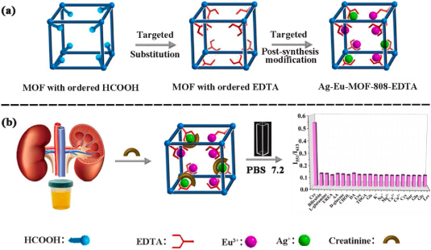
Figure 5. Schematic illustration of the three-step Ag-Eu-MOF-808-EDTA synthesis and the fluorescence working principle. Reproduced with permission [61]. Copyright 2022 Elsevier.

Ma et al. developed a mixed Cd/Cu-based MOF for electrocatalytic oxidation of uric acid (UA) using post-synthetic metal exchange [62]. They started with a Cd/macrocycle-based MOF ([Cd5O(L)(H₂O)₄]·4DMF·5H₂O, Cd-L) and replaced the Cd(II) ions with Cu(II) ions, resulting in [Cd₄OCu(L)(H₂O)₄]·DMF·7H₂O (CdCu-L) (Figure 6). This substitution tripled the conductivity. The CdCu-L electrode effectively detected UA in real samples, with a detection range of 10 to 500 μM and a detection limit of 2.67 μM. The electrode also showed excellent selectivity, reproducibility, and stability.

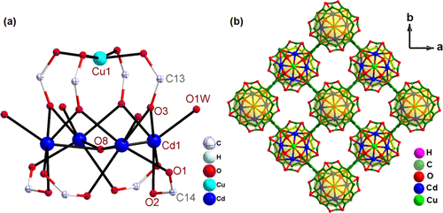
Figure 6. (a) Pentanuclear Cd–O cluster in Cd-L. (b) View of the 2D layer for Cd-L along the ab plane. Reproduced with permission [62]. Copyright 2022 ACS.
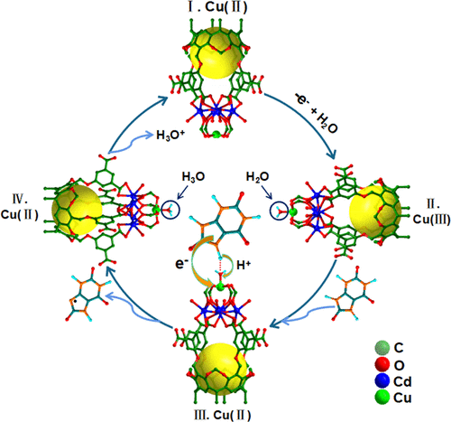
Figure 7. Possible catalytical mechanism of CdCu-L/GCE for the oxidation of UA. Reproduced with permission [62]. Copyright 2022 ACS.
3.2.2. Template-assisted MOF synthesis
Template-assisted MOF synthesis employs external templates such as organic molecules or polymers to regulate the nucleation and growth of MOFs during their creation, which enables precise control over the MOF morphology and properties [63]. Recently, mesoporous ZIF-8 was assembled to immobilize cytochrome c (Cyt c) using a sacrificial template method [64]. The as-fabricated templated sensor, Cyt c@mesoZIF-8/SPE, was used for the efficient electrochemical detection of H₂O₂ (Figure 8).
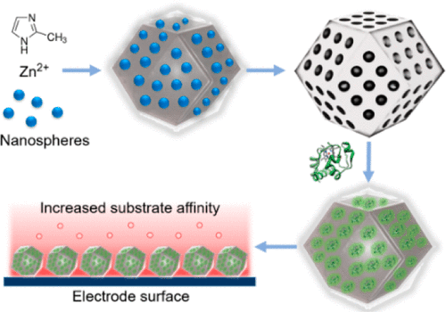
Figure 8. Synthesis of Cyt c@mesoZIF-8 and the detection of H₂O₂ with a Cyt c@mesoZIF-8/screen-printed electrode (SPE). Reproduced with permission [64]. Copyright 2017 ACS.
CPs have also been studied for template-assisted synthesis of biosensors. Sapountzi et al. studied the synthesis of polyacrylonitrile/polypyrrole core-shell nanofibers and their application in glucose biosensors [65]. They developed a two-step method involving electrospinning and vapor-phase polymerization to deposit conductive polypyrrole layers on gold electrodes coated with polyacrylonitrile (PAN) nanofiber mats. Initially, PAN fibers with an average diameter of 650 ± 10 nm were electrospun from 12 wt% PAN solutions. These fibers were then impregnated with iron(III)tosylate (FeTos), annealed, and used as a template for the growth of a conductive polymer layer through the copolymerization of pyrrole (Py) and pyrrole-3-carboxylic acid (Py3COOH) vapors under a nitrogen atmosphere. The incorporation of carboxyl groups into the polypyrrole coatings facilitated the covalent binding of glucose oxidase, serving as a model enzyme. Researchers systematically investigated the influence of various parameters (FeTos concentration in the immersion solution, polymerization time, and Py/Py3COOH molar ratio) on the biosensor response. Under optimized conditions (PAN fibers immersed in a 20 wt% FeTos solution, 30 minutes of polymerization, 1:2 Py/Py3COOH ratio), the biosensor demonstrated a linear response over a wide range of glucose concentrations (20 nM−2μM) and exhibited selectivity towards ascorbic and uric acids. Remarkably, they achieved a very low limit of detection (2 nM), enabling the accurate determination of glucose levels in human serum even after significant sample dilution within the normal concentration range (3.6−6.1 mM).
3.2.3. Mixed-linker synthesis
Mixed-linker synthesis of MOFs represents a sophisticated design approach in which two or more organic linkers are integrated concurrently during the production process [66]. This method enables the creation of MOFs with finely tuned properties and augmented functionalities, surpassing the limitations of single-linker systems [67]. Through the meticulous selection and combination of diverse linkers, researchers can precisely engineer the structure, pore characteristics, and surface chemistry of the resultant MOFs, thereby broadening their utility across applications in sensing.
Tan et al. introduced a one-step process to create an aluminum-based MOF using a combination of linkers, improving its ability to adsorb water vapor [68]. Through rational control of the synthetic conditions, the one-pot synthesis process is expected to provide an easy and inexpensive way to tune the properties of mixed MOFs for the desired applications. In a separate study, Fan et al. used a solvothermal method to produce coordination polymers, Cu(tptc)_{0.5}(phen)]_{n} and [Cd(tptc)_{0.5}(phen)]_{n}, demonstrating strong electrochemical features and dual sensing capabilities for metal ions and organic substances [69].
3.2.4. Self-Assembly of building units
The self-assembly procedure usually involves combining metal ions or clusters with organic ligands in environments with appropriate temperature, solvent choice, and pH level. Subsequently, these components spontaneously organize into a specific crystal lattice pattern determined by the coordination preferences of the metal ions and connectivity of the organic ligands. Key factors driving self-assembly in the synthesis of MOFs comprise coordination chemistry, hydrogen bonding, π-π stacking interactions, and van der Waals forces. Therefore, controlling the reaction parameters plays a significant role in determining the properties and performance of MOFs for specific applications. Recently, Afzalinia et al. reported a novel La(III)-MOF and silver nanoparticles in a sandwich-type fluorescence resonance-based energy transfer (FRET)-hybridized oligonucleotide for rapid and highly selective biosensor applications, with a higher sensitivity for detecting MicroRNA-155 (miRNA-155) as a cancer biomarker [70]. The MOF and Ag NPs acted as energy donor-acceptor pairs during fluorescence quenching through the FRET process. The as-prepared biosensor material performs in high sensitivity with a limit of detection of 0.0386 ppb; additionally, the high selectivity and good applicability of this biosensor in real clinical serum are advantages of this protocol. Chang et al. reported a homogeneous electrochemical biosensor using UiO-66-NH2 and dsDNA, as shown in Figure 9 [71]. UiO-66-NH2 was employed to take advantage of its highly porous surface area as a nanocontainer of dsDNA, which is an electroactive dye used as a gatekeeper to cap MOFs. Two functionalized MOFs, MB@UIO and TMB@UIO, were prepared and applied for the simultaneous detection of the proof-of-concept analytes, let-7a and miRNA-21. Both let-7a and miRNA-21 belong to the miRNAs and are promising tumor biomarkers for cancer diagnosis and therapy. Moreover, ultrasensitive and selective label-free non-enzymatic homogeneous electrochemical detection has been developed for the early detection of tumor biomarkers.
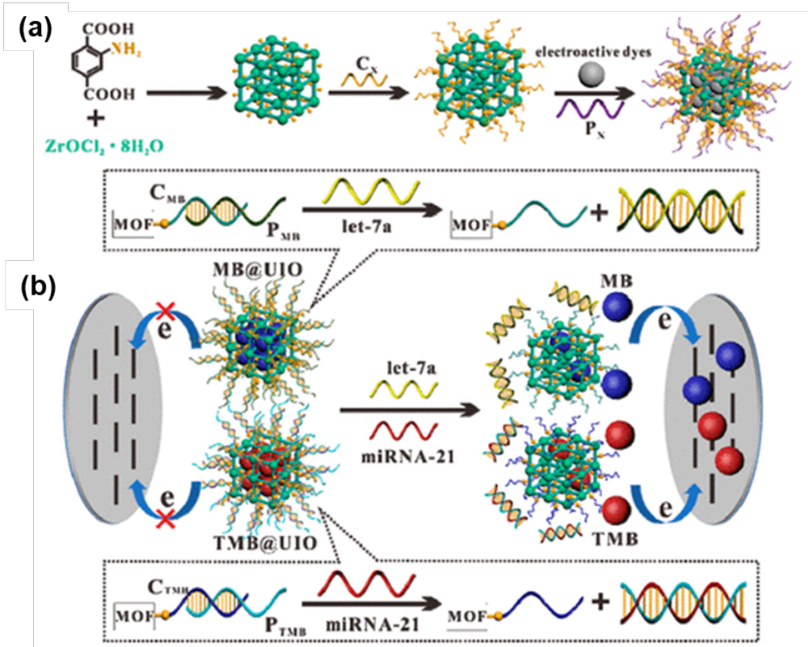
Figure 9. (a) Schematic representation of the production procedure nucleic acid-functionalized MOFs and (b) the principle of the MOF-based homogeneous electrochemical biosensor for multiple detection of miRNAs. Reproduced with permission [71]. Copyright 2019 ACS.
3.2.5. Core-shell structure of MOFs
A core-shell structure within MOFs denotes a configuration in which one component constitutes the core, often a metal cluster or another MOF, whereas another component forms the shell, typically an organic ligand or a distinct MOF [72]. This structural design yields advantageous properties such as enhanced stability, customizable functionality, and versatility. Different studies have been conducted to exploit the excellent physicochemical properties of the core-shell structure assembly. Yu et al. reported that CuO/Cu₂O@CuO/Cu₂O core-shell nanowire arrays (NWAs) were first synthesized by the calcination of the famous HKUST-1 MOF for application in nonenzymatic glucose sensing [73]. This configuration has been proven to improve the traditional prevalent aggregation of MOF particles when used in a particle manner, and this route provides ample diffusion sites in which the ions can actively interact with the sensor, which in turn boosts the biosensor performance of the as-prepared material. The as-prepared NWAs have a higher sensitivity (10,090 μA mM⁻¹ cm⁻²), low detection limit (0.48 μM), and wide linear range (0.99–1,330 μM) for glucose sensing. They also show excellent anti-interference ability towards uric acid, ascorbic acid, and L-cysteine coexisting with glucose; good reproducibility; and superior ability in real sample analysis.
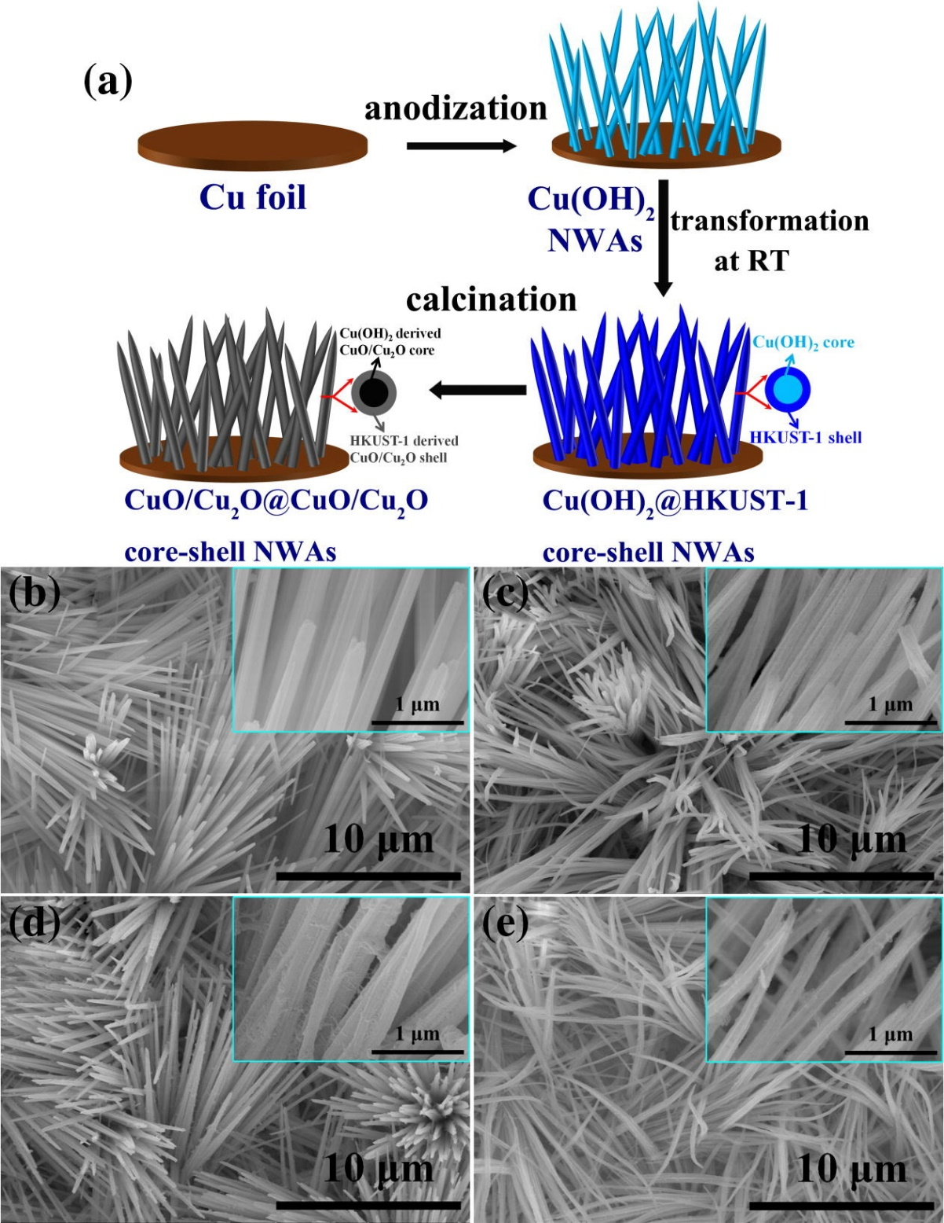
Figure 10. (a) Schematic illustration of the production process of CuO/Cu₂O@CuO/Cu₂O core-shell NWAs on Cu foil, FESEM images of (b) Cu(OH)₂ NWAs, (c) Cu(OH)₂ derived CuO/Cu₂O NWAs, (d) Cu(OH)₂@HKUST-1(8) core-shell NWAs, and (e) Cu(OH)₂@HKUST-1(8) derived CuO/Cu₂O@CuO/Cu₂O(8) core-shell NWAs. (Insets show the corresponding FESEM images with high magnification). Reproduced with permission [73]. Copyright 2018 Elsevier.
In addition to MOFs, CP-based biosensors can be fashioned using core-shell architectural configurations. Sun et al. devised Au NPs@GMP-Tb ICPs, a core-shell nanocomposite integrating gold nanoparticles within fluorescent GMP-Tb³⁺ polymers. This composite functions as a dual-channel sensor for detecting ATP-related phosphates and monitoring ATP hydrolysis [74]. The interaction between Tb³⁺ and P-O bonds modulates the response of Au NPs@GMP-Tb ICPs to various phosphates, thereby regulating both fluorescence intensity and UV-vis absorbance. These sensors offer interference resistance and enhanced analyte detection, advancing "lab-on-a-nanoparticle" systems for precise chemical reaction monitoring.
3.2.6. Defect design
Defect engineering offers researchers an opportunity to tailor the properties of MOFs and CPs for specific applications [75]. These defects can arise from various sources, such as the absence of linkers or metal ions, voids within the framework, or the inclusion of guest molecules during synthesis [76]. Additionally, defects may result from flaws in the synthesis process or postsynthetic treatments.
Recently, Luo et al. introduced a novel approach to develop a conductive 2D MOF tailored for use in electrochemical sensors for H₂O₂ [77]. The produced Cu-BHT MOF was synthesized by employing a straightforward and versatile defect engineering methodology aimed at regulating metal vacancies within metal benzenehexathiolato (BHT) coordination polymer films. With a focus on sensor applications for ensuring food safety, the synthesized MOF leverages defects to effectively structure and integrate materials. Precise control of atomic defect engineering yields an abundance of Cu²⁺ vacancies, which serve as active sites for both H₂O₂ adsorption and reduction. Furthermore, the study demonstrated that the modulation of vacancies in the electronic structure optimized the adsorption energy and electron transfer processes during H₂O₂ reduction. MOFs synthesized based on the reported defects exhibited outstanding electrochemical sensor performance, characterized by superior sensing parameters, prolonged stability, and robust resistance to interference.
3.3. Composite MOFs for electrochemical biosensors
In recent decades, considerable research has been conducted on composite MOFs and CPs for their potential application in electrochemical biosensors [78]. This interest is driven by their advantageous features, including large surface area, adjustable pore size, and chemical versatility, all of which facilitate the effective immobilization of biomolecules and consequently enhance sensor performance (Table 1). Additionally, by incorporating supplementary materials such as conductive polymers or metal nanoparticles, these composite structures exhibit notable synergistic electrochemical properties, thereby enhancing sensitivity and stability [79]. Various methodologies have been employed to synthesize composite MOFs and CPs, offering diverse avenues for the development of efficient biosensors.
3.3.1. Metal-nanoparticle-based composite MOFs
Metal-based nanoparticles have been incorporated into MOFs and CPs to enhance the electrical conductivity and electrochemical performance for biomolecule detection. Zha et al. presented a highly effective biosensor capable of dual electrochemical and photoelectrochemical sensing, as shown in Figure 11 [80]. This biosensor utilized Nd-MOF nanosheets modified with an ionic liquid and gold nanoparticles (Au NPs) and was specifically designed to detect circulating DNA (ctDNA) associated with triple-negative breast cancer. The Au NPs functioned as both photoactive agents for generating photochemical signals and as active substrates for anchoring biorecognition elements. The resulting biosensor demonstrated impressive analytical performance, featuring a linear detection range of 1.0 fmol L⁻¹ to 10.0 nmol L⁻¹ and 1.0 fmol L⁻¹ to 1.0 nmol L⁻¹ for ctDNA. The limit of detection was 0.63 fmol L⁻¹ and 0.30 fmol L⁻¹ for the photoelectrochemical and electrochemical sensing modes, respectively. This dual-mode biosensor showed exceptional early-stage detection of ctDNA with enhanced selectivity, accuracy, stability, and reproducibility, which was attributed to the synergistic interactions among its constituent components.
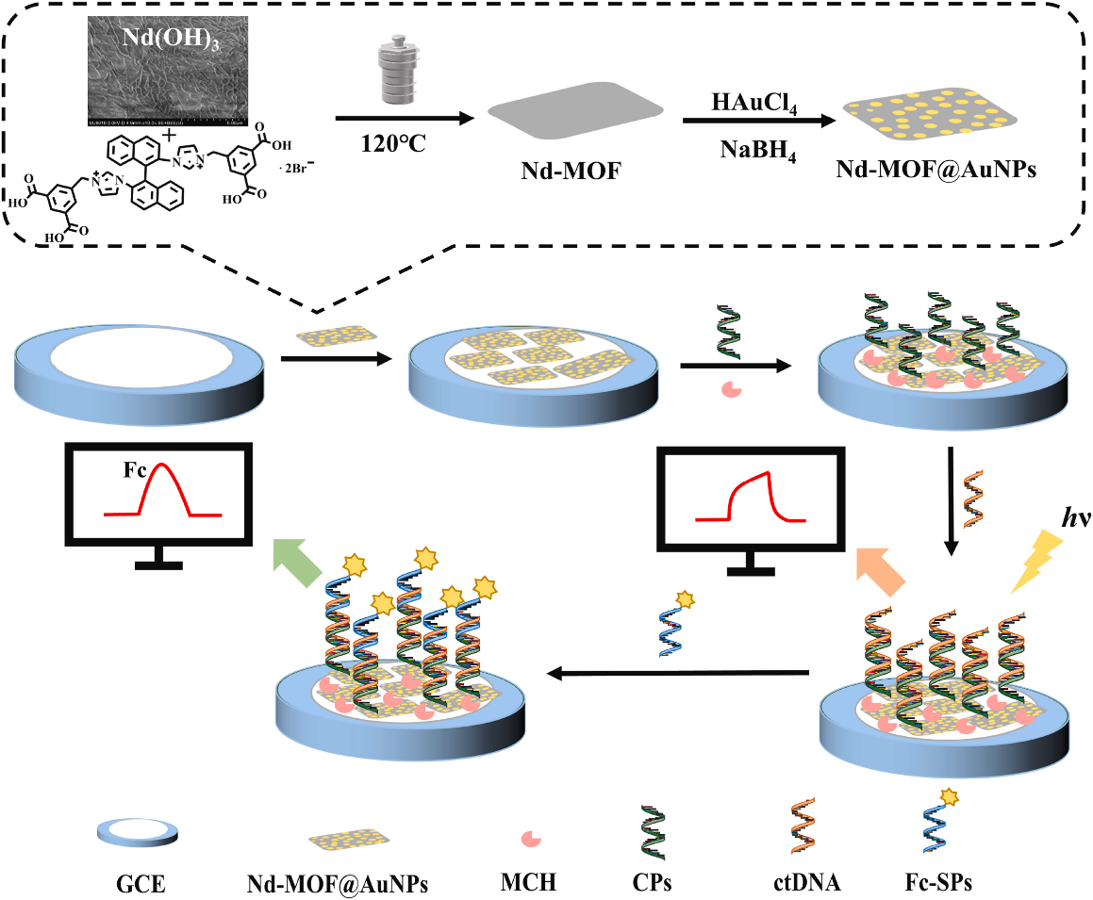
Figure 11. Schematics of the Nd-MOF@AuNPs nanocomposites synthesis and a PEC-EC dual-model ctDNA biosensor preparation. Reproduced with permission [80]. Copyright 2023 Elsevier.
In another study, AuNPs were integrated into the MOF to create an efficient biosensor. Liang et al. detailed the development of Au/Cu-MOF/SWNH nanomaterials, wherein a sensitive dual-signal sandwich-type electrochemical immunosensor was devised to detect Neutrophil Gelatinase-Associated Lipocalin (NGAL) in early-stage acute kidney injury (AKI) [81]. This material demonstrated an optimal linear range of 0.00001–10 ng·mL^{–1} and detection limits of 0.0074 pg·mL^{–1} (SWV). The synthesized composite materials exhibited enhanced sensor activity, which was attributed to their elevated surface areas and electrical conductivities. The former quality stems from the Cu-MOF, whereas the latter results from the metal node and Au NPs. The electrochemical signal was derived from the electron transfer between Cu²⁺ and Cu⁺ ions with the incorporation of Au NPs, further enhancing the electroconductivity of the biosensor.
3.3.2. Polymeric-based composite MOFs
The integration of polymeric materials with MOFs and CPs to form composite materials is a promising research topic. These composites exploit the combined properties of their constituent elements to yield enhanced electrochemical biosensor capabilities [82]. Recently, ru(dcbpy)32⁺-polyethyleneimine-L-lysine (Ru-PEI-L-lys)-immobilized ZIF-8 (Ru-PEI-L-lys-ZIF-8) was developed as an efficient electrochemiluminescent (ECL) indicator for thrombin detection [83]. PEI-L-lys was used as a co-reactant in the ECL biosensing process, and platinum nanoparticles (PtNPs) were incorporated to form a thin film on the composite MOF to increase the electron transfer and electrical conductivity of the composite materials, thus enhancing the ECL performance. The as-prepared biosensor had a linear thrombin concentration range of 1–10 pM, with a detection limit of 0.02 aM. Therefore, the incorporation of polymers into ZIF-8 yielded a composite material with enhanced ECL properties.
Moreover, Hira et al. reported a low-cost, environmentally friendly approach for developing a copolymer-grafted metal-organic framework synthesis route for electrochemical sensors for dopamine (DA) and H₂O₂ detection [84]. As-prepared UiO-66-NH₂@P(ANI-co-ANA) owns a wide linear range of 25–500 μM and 10–110 μM for H₂O₂ and DA, respectively. The sensitivity and limited detection of DA in the human urine sample were 1110.2 μAμM⁻¹cm⁻² and 0.3 µM, respectively. By compositing these two materials, more adsorption sites were obtained for UiO-66-NH₂, whereas polyaniline and poly(anthranilic acid) were used to enhance the electrical conductivity of the composite biosensor, as confirmed by the CV test (Figure 12).
In the realm of composite formulation, PEDOT has been investigated for the advancement of electrochemical biosensors. Owing to its high conductivity, biocompatibility, flexibility, and transparency, integrating this material into a MOF matrix is expected to yield biosensor materials with remarkable efficiency and effectiveness [85]. Recently, a ZIF-8@poly (3, 4-ethylene dioxythiophene):poly (styrene sulfonate) (PEDOT: PSS) composite was synthesized and used for the electrochemical sensing of dichlorophenol [86]. The as-prepared ZIF-8@PEDOT:PSS composite material owned excellent electrochemical activities for dichlorophenol detections with a wide linear range response of 0.03 ~10.0 μM and a low limit of detection of 0.01 μM. The as-prepared composite material exhibited high conductivity, electrocatalytic activity, and stability. This was attributed to the structural advantage of the composite materials; the matrix ZIF-8 provided an ample porous surface area for the enhanced adsorption of dichlorophenol and the PEDOT:PSS coating of ZIF-8 increased the conductivity and catalytic activity of the matrix material.
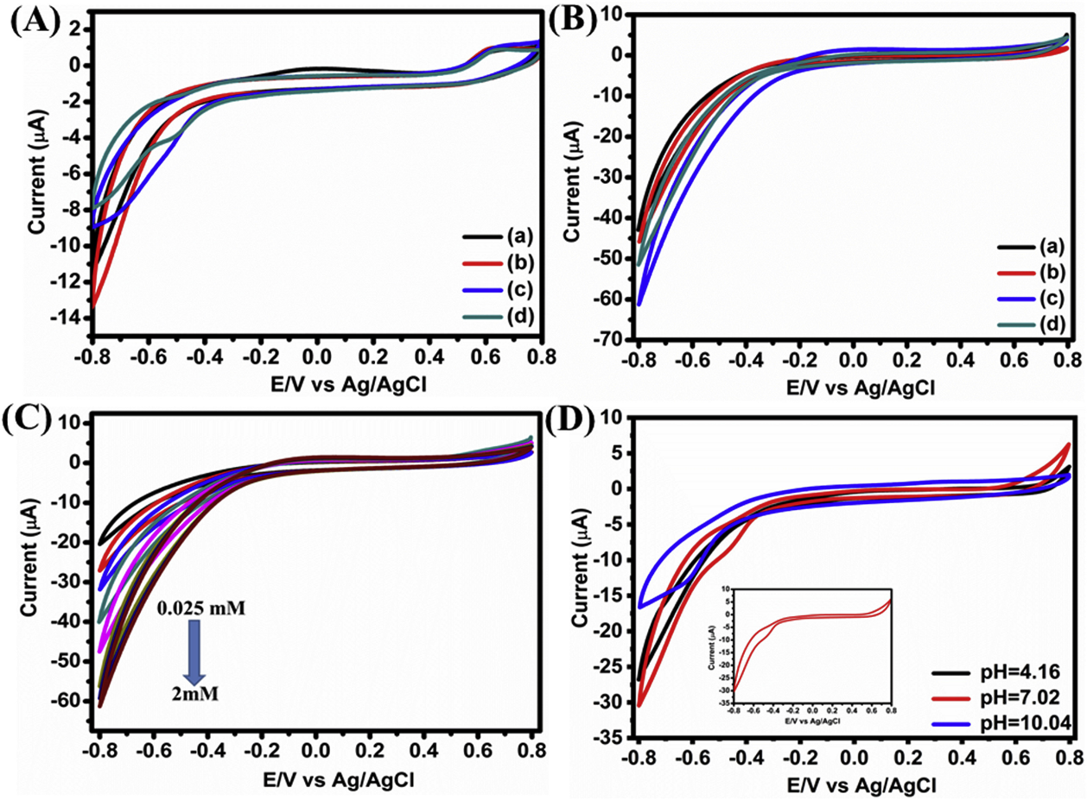
Figure 12. (A) CVs of the modified electrodes in 0.1 M PBS (pH = 7.02) solution in the absence of H₂O₂ at a scan rate of 50 mVs⁻¹, UiO-66-NH₂ (a), UiO-66-NO₂ (b), UiO-66-NH₂@P(ANI-co-ANA) (c) and UiO-66-NO₂@P(ANI-co-ANA) (d). (B) CVs of similar electrodes in 0.1 M PBS (pH = 7.02) solution containing 0.5 mM of H₂O₂. (C) CVs of UiO-66-NH₂@P(ANI-co- ANA)/GCE in 0.1 M PBS (pH = 7.02) at different concentrations of H₂O₂ (0.025 μM–2 mM). (D) CVs of UiO-66- NH₂@P(ANI-co-ANA)/GCE in 0.5 mM H₂O₂ at various pHs. Reproduced with permission [84]. Copyright 2020 Elsevier.
3.3.3. Carbon material-based composite MOFs
Carbon-based composite materials have significant potential in enhancing MOF-based composite biosensors for biomedical applications. These materials offer a combination of biocompatibility, conductivity, surface area, stability, flexibility, and versatility, which is crucial for the development of sensitive, selective, and dependable biosensors for diverse healthcare applications [87]. Rong et al. reported an MB@MWCNTs/UiO-66-NH2 composite material for the ratiometric electrochemical detection of the antitumor drug doxorubicin [88]. In this study, the inclusion of MWCNTs resulted in higher electrical conductivity. The as-prepared biosensor has a wide linear detection range of 0.1–75 μM and a limit of detection of 0.051 μM. Compared to traditional electrocatalytic electrochemical methods, the as-prepared electrode ratiometric electrochemical sensor contributes to analyte signal amplification with high selectivity and stabilization.
3.3.4. Nanoparticle formation of MOFs
Nano-MOFs, which are synthesized at the nanoscale, possess distinctive characteristics owing to their size and configuration [89]. Nano-MOFs offer several benefits in biosensor applications. Nano-MOFs exhibit substantial potential for biosensor applications, offering distinct properties that can address fundamental biosensing challenges such as sensitivity, selectivity, stability, and integration [90]. Ongoing refinement and enhancement are expected to yield highly effective and adaptable biosensors that can be used in a broad spectrum of biomedical and environmental applications [91]. Hu et al. reported that Cr-MOF nanoparticles can be loaded onto a GCE to serve as an efficient electrochemical platform for detecting p-nitrophenol (p-NP) [92]. This sensor demonstrates a low detection limit of 0.7 μM for p-NP within a broad concentration range of 2–500 μM. Furthermore, these sensors exhibit strong performance even in the presence of competing analytes. Considering the benefits of their porous structure and straightforward synthesis strategy, Cr-MOFs were investigated for potential applications in the sensor field. The Cr-MOF nanoparticles displayed significant electrocatalytic activity towards p-NP, and the sensor was successfully validated for p-NP detection in river water, underscoring its practical utility.
3.4. Applications strategy of an MOF-based biosensor
Diverse methodologies have been investigated to deploy MOF-based biosensors, whether utilized individually or in a composite form. These biosensors can be employed using various techniques, including ratiometric, enzymatic, nonenzymatic, optical, and electrochemical [56,93]. Recently, Zhang et al. reported a bimetallic-based MOF composite electrode, Nafion/Co/MnO@HC/GCE, as an excellent in vitro nonenzymatic electrochemical biosensor for glucose detection [40]. The as-prepared electrode had a wide range of electrocatalytic activity of 50–900 μM with a sensitivity of 233.8 μA mM⁻¹ cm⁻². The detection limit of this electrode was 1.31 μM. The application of this composite electrode to real serum samples showed excellent reproducibility, anti-interference, and stability. The synergy between the bimetallic component and high surface area, along with multiple active sites, is considered responsible for the efficient detection of glucose in alkaline media. In the development of composite materials, it is worth noting that heat treatment of MOFs results in improved physicochemical performance of the biosensor materials. Recently, a novel copper oxide-based composite biosensor was developed (CuOx@mC/GCE) as an electrochemical sensor for the enhanced nonenzymatic detection of pesticides (glyphosate) [94]. HKUST-1 cells were loaded onto glassy carbon electrodes (GCE). The composite pyrolyzed form of the MOF, CuOx@mC, showed an enhanced electrochemical response compared to the parent HKUST-1 material. The CuOx@mC/GCE exhibits superior electrochemical performance with an ultralow detection limit of 7.69 × 10⁻¹⁶ M toward glyphosate over a linear range of 1.0 × 10⁻¹⁵ to 1.0 × 10⁻⁴ M. Such ultrasensitive sensors have been realized following the thermal treatment of HKUST-1, which is believed to enhance the mesoporous structure and electrical conductivity; thus, the overall electrochemical sensitivity is improved.
Advanced manufacturing methods and composite techniques have led to the creation of composite materials with dual functionalities for both analysis and sensing. Xue et al. showcased a method utilizing Cu-MOFs to enhance electrochemical biosensing of microRNA through CHA-HCR dual-amplification (Figure 13) [95]. This approach involves immobilizing Cu-MOFs on electrodes to boost signals, with CHA and HCR amplifying input signals. These composite biosensors allow sensitive detection of miR-21 across a wide linear range (0.1 fM to 100 pM) and with a low detection limit (0.02 fM).

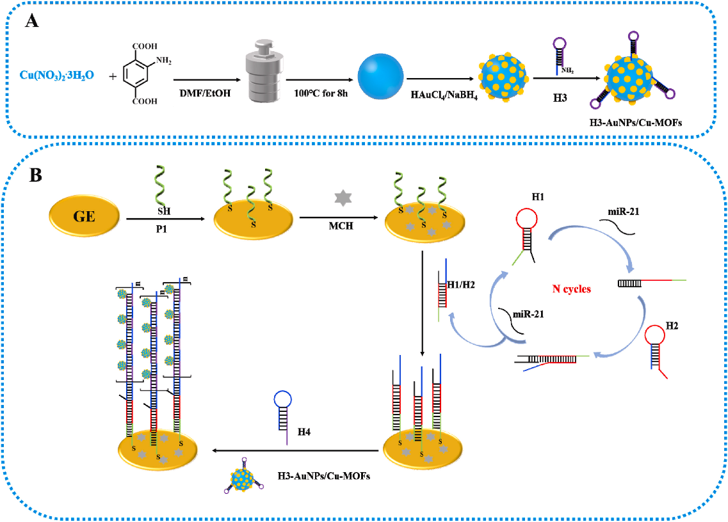
Figure 13. Schematic illustration of the production procedures of H3-AuNPs/Cu-MOFs (A) and an electrochemical biosensor for the detection of miR-21 (B). Reproduced with permission [95]. Copyright 2022 Elsevier.
3.4.1. Biofunctionalization of MOFs
Utilizing DNA to modify MOFs is crucial for various bio-applications, such as targeted biomolecular sensing, biocatalysis, bioimaging, and theranostics. By employing DNA programming, MOFs can specifically adhere to biomolecules or cell receptors, thereby improving the biosensing accuracy [96]. Additionally, DNA-functionalized MOFs serve as adaptable platforms for biosensing, aiding the identification of pathogens, and disease indicators [97]. Incorporating enzymes into MOFs through DNA hybridization boosts biocatalytic processes across a range of applications. Furthermore, by incorporating fluorescent or luminescent markers into the DNA-modified MOFs, their bioimaging capabilities can be enhanced, offering valuable insights into their biological functions. Liu et al. presented a pioneering methodology involving the integration of DNA-functionalized MOFs to enhance the detection sensitivity through T7 exonuclease-aided recycling amplification. This innovative approach was used to detect immobilization-free carcinoembryonic antigen (CEA) via in vitro photoelectrochemical (PEC) detection [96]. In their study, UiO-66-NH2 acted as a nanocarrier for electron donors, while a tailored hairpin probe detected CEA through a conformational change, initiating T7 exonuclease-mediated amplification. This process released electron donors, significantly increasing the photocurrent. With high sensitivity and selectivity, the biosensor detected CEA with a limit of 0.36 fg mL⁻¹ and a range from 1.0 fg mL⁻¹ to 10 ng mL⁻¹, showing promise for early disease diagnosis in human serum analysis. In another study, MOFs were adapted with various proteins for biodetection. Trino et al. developed a label-free electrochemical biosensor using ZIF-8 to monitor protein-protein interactions [98]. This biosensor, hosting Trx-1, effectively detected interactions with ADAM17cyto, showing superior sensitivity compared to conventional assays. The approach offers a rapid, label-free, and cost-effective strategy for detecting in vitro PPIs, showcasing the potential of protein-functionalized MOFs in biomedical applications.

3.5. CPs in electrochemical biosensing
Coordination polymers (CPs) are a compelling candidate for biosensing applications because of their inherent characteristics. In addition to their remarkable topological properties and inherent stability, their structural responsiveness to target binding enables precise and reliable signal transduction, and their stability and biocompatibility underscore their suitability in diverse biomedical contexts, including multiplexed detection, and in vivo sensing.
3.5.1. Two-dimensional CP assembly
The utilization of two-dimensional (2D) CPs in biosensors offers notable advantages. Their flat geometry provides an expansive surface area, facilitating efficient biomolecule immobilization, thereby enhancing binding capacity and sensitivity [99,100]. Moreover, their customizable properties, including pore size and surface chemistry, enable the tailored optimization of specific analytes and ensure precise detection. These polymers demonstrated robust stability under physiological conditions, ensuring a consistent and reliable performance. Additionally, their structural integrity allows the simultaneous multiplexed detection of multiple analytes, making them invaluable tools for medical diagnostics and environmental monitoring [101]. Overall, two-dimensional coordination polymers represent a promising platform for the development of highly sensitive, selective, and stable biosensors with diverse applications. Fu et al. described the creation of a hydrogen-bonded 2D coordination polymer (CP1) for non-enzymatic glucose sensing, which is crucial for effective diabetes management [102]. The nonenzymatic electrochemical glucose biosensor was synthesized from melamine (Mel), biphenyl-4,4′-dicarboxylate (BPDC²⁻) co-ligands, and Zn(II) metal nodes, and denoted as CP1, for the 2D layered glucose sensor. The layers are interconnected through hydrogen bonding interactions among the melamine molecules. The CP1/GCE the in vitro-based sensor displayed accurate clinical performance, with a broad linear sensing range from 5.6 μM to 5.56 mM (R2 = 0.9852) and a high sensitivity of 517.36 μA mM⁻¹ cm⁻². The as-prepared biosensor exhibited an enhanced CV conductivity, as shown in Figure 14. The low detection limit of the as-prepared CP1 is 80 μg (8 μL, 10 mg ml⁻¹). The stability of CP1/GCE in weakly acidic and weakly basic media supports its application in aqueous solution sensing.
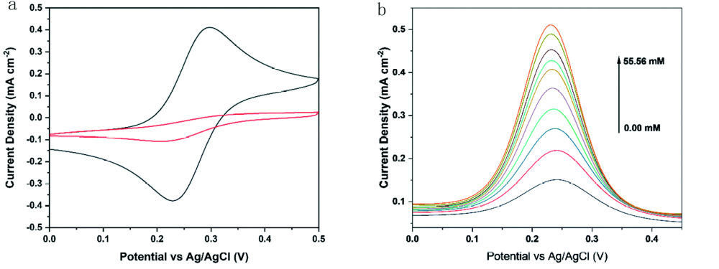
Figure 14. (a) CV characterization of the CP1 modified electrode in a K₃[Fe(CN)₆]/K₄[Fe(CN)₆] solution containing 0.5 mM KCl at pH 7: bare electrode (i, black), CP1/GC (ii, red), scan rate 100 mV s⁻¹; (b) DPV performance of a CP1 modified electrode from 0–55.56 mM in a K₃[Fe(CN)₆]/K₄[Fe(CN)₆] solution containing 0.5 mM KCl at pH 7.5 for glucose detection. Reproduced with permission [102]. Copyright 2022 ACS.
3.5.2. Inorganic material composites of CPs
Blending inorganic metals with CPs enhances the performance of electrochemical biosensors by improving sensitivity, selectivity, biocompatibility, stability, functionality, and fabrication flexibility [103]. This combination exploits the distinct properties of both materials to create adaptable sensors capable of detecting various analytes in complex samples (Table 1) [104]. Recently, ferrocene (Fc)-based polymers have gained recognition as essential redox agents in glucose biosensors [105]. Poly-L-lysine (PLL), known for its cationic nature and desirable characteristics like biocompatibility, biodegradability, and water solubility, underwent modification with ferrocene carboxylate. The resultant redox mediator (Fc-PLL), in conjunction with glucose oxidase (GOx) enzyme, displayed improved oxidation current in the presence of glucose in PBS (pH 7.4), as observed through cyclic voltammetry. Amperometry revealed a linear detection range from 0 to 10 mM, with a detection limit of 23 μM and a sensitivity of 6.55 μA/cm2 mM, along with strong selectivity. Scanning electrochemical microscopy confirmed the significant activity of Fc-PLL/GOx on the electrode surface, establishing Fc-PLL redox polymer as a valuable material for glucose biosensing, facilitating electron transfer between the redox polymer and GOx.
Zahed et al. developed a new electrochemical biosensor for detecting glucose and pH levels in human sweat [106]. The sensor features a flexible and conductive base made of PEDOT anchored to a porous graphene network. Pt and Pd nanoparticles were added to enhance its electrocatalytic activity for glucose detection. The biosensor showed wide detection range, high sensitivity, and low detection limit. Testing with sweat samples validated its effectiveness for biosensing applications.

Polymeric materials can be printed onto inorganic nanomaterials to produce effective electrochemical biosensors. Bai et al. developed IgG imprinted polymers using metal-free visible light-induced atom transfer radical polymerization (MVL ATRP) for biosensors [107]. These polymers were deposited onto a nano-Au/nano-Ni-modified Au electrode (Figure 15). The resulting biosensor exhibited a wide linear range and low detection limit for IgG detection using differential pulse voltammetry (DPV), offering a convenient and nontoxic method for IgG determination.
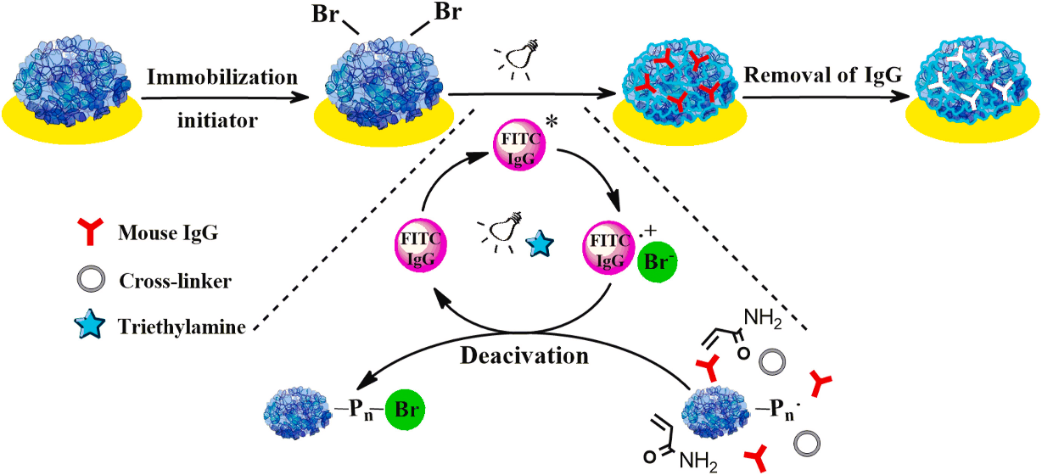
Figure 15. Schematic preparation process of IgGIPs/AuNCs/NiNCs/Au via MVL ATRP. Reproduced with permission [107]. Copyright 2021 Elsevier.
Furthermore, a widely recognized semiconductor material, titanium dioxide (TiO₂), has been employed as a composite material to achieve superior electrochemical biosensor performance. Yang et al. demonstrated the impressive electrochemical biosensing capabilities of a composite material based on CP and TiO₂ [101]. They synthesized a composite biosensor by combining TiO₂ and a conducting polymer (CP) using Cu(I), chloride ions, and 4-mercaptobenzoic acid (MBA), termed CuClx(MBA)y. This enabled the development of a sensitive photoelectrochemical (PEC) biosensor for microRNA-21 detection. The biosensor showed a low detection limit of 0.29 fM (S/N = 3), excellent selectivity, and reproducibility. It has been successfully employed clinically to monitor miRNAs in cancer cells with promising results.
3.5.3. Organic materials-based composite CPs
The investigation of conducting polymers has resulted in a fascinating turn in the production of effective biofouling-free biosensors. Han et al. have introduced an innovative strategy to address biofouling challenges in the direct detection of circulating tumor cells (CTCs) in human blood [108]. Their electrochemical biosensor integrates a multifunctional peptide and electrodeposited conducting polymer, poly(3,4-ethylene diox-ythiophene) (PEDOT). The peptide exhibits antifouling properties and specific recognition capabilities for capturing MCF-7 breast cancer cells, while PEDOT enhances electron transfer at the sensing interface, thereby improving sensitivity. Through the synergy of the peptide and PEDOT, the biosensor can operate directly in blood samples without the need for complex purification or separation steps. It demonstrated a wide linear detection range and low LOD, even in the presence of 25% human blood (in vitro), indicating robustness against biofouling. This study presents a promising advancement for direct CTC analysis in human blood, with potential implications for liquid cancer biopsy procedures.
Organic materials have been used as composite materials with polymer matrices to develop effective electrochemical biosensors. Popov et al. conducted research on developing an amperometric glucose biosensor utilizing a nanocomposite composed of reduced graphene oxide (rGO) and polyaniline nanofibers [109]. The precise monitoring of glucose concentration holds paramount importance in clinical diagnostics and the food industry, thus prompting the exploration of electrochemical biosensors integrating rGO and conducting polymers. The biosensors were fabricated by combining rGO with polyaniline (PANI), Nafion, and glucose oxidase (GOx). A graphite rod (GR) electrode, pre-modified with a blend of PANI nanostructures and rGO, Nafion, and GOx, served as the working electrode. Through experimentation, the optimal PANI ratio in the dispersion for GOx immobilization was determined to be 1:10. The resulting glucose biosensor demonstrated a wide linear range (0.5 to 50 mM), a low detection limit (0.089 mM), and exhibited exceptional selectivity, reproducibility, and stability. Consequently, it was deemed suitable for precise glucose determination in human serum. This study highlights the potential of PANI nanostructures and rGO dispersions in advancing the development of electrochemical glucose biosensors.

Furthermore, current research is directed towards the integration of conductive polymers into controlled synthetic environments within the field of CPs. Yang et al. conducted a study on the application of PEDOT as a dopant for crosslinking conductive polymer hydrogels (CPHs), with a focus on potential applications in bioelectronics [110]. The proposed method involves using PEDOT to crosslink various conductive polymers, such as polyaniline (PAni), polypyrrole (PPy), and polyaminoindole (PIn-X-NH2, X = 4, 5, 6, 7). The synthesis mechanism relies on electrostatic interactions between the negatively charged SO³⁻ groups in PEDOT and the positively charged polymer chains. Compared to PA-crosslinked CPHs, those crosslinked with PEDOT demonstrated significantly improved conductivity and enhanced biocompatibility, essential characteristics for bioelectronic applications. These PEDOT CPHs hold promise as electroactive materials for in vivo electrochemical sensing of bioactive molecules, such as dopamine and hydrogen peroxide, released from living cells.

Moreover, CP functionalization has been investigated for the development of efficient biosensors. The functionalization process allowed us to obtain the combined effect of the CP matrix and the compositing materials. Fedorenko et al. documented the in vitro application of PDA-functionalized ZnO for the development of a glucose biosensor [111]. Zinc oxide (ZnO) nanostructures, commonly used in optics and biosensors, were enhanced for photo-electrochemical sensing by coating them with the biocompatible polymer, polydopamine (PDA). This involved growing ZnO nanorods on indium tin oxide (ITO)-modified glass substrates followed by the addition of a PDA layer. Glucose oxidase (GOx) was immobilized onto the resulting ZnO-PDA surface to create a biosensing platform for detecting glucose in water. This study demonstrated the improved performance of PDA-modified ZnO nanorods for photoelectrochemical sensing applications.
Table 1. Comparison of different biosensor materials.
Methods/Sensor | Target analyte | Detection limit (μM) | Sensitivity  (μAcm⁻²mM⁻¹) | Ref.
GOD-GA-Ni/Cu-MOFs-FET | Glucose | 0.51 | 26.05 | [112]
PP/LIG | Glucose | 3 | 247.3 | [106]
Ru-PEI-L-lys-ZIF-8 | Thrombin | 2 x 10⁻¹⁴ | - | [83]
JUC-1000 | TNP | 3.46 x 10⁻¹⁷ | - | [113]
CuO/Cu₂O@CuO/Cu₂O | Glucose | 0.48 | 10,090 | [73]
CP1/GCE | Glucose | 80 x 10⁻⁷ | 517.36 | [102]
Poly-L-lysine | Glucose oxidase | 23 | 6.55 | [105]
GR/PANI-AuNPs(6 nm)-GOx/GOx | Glucose oxidase | 70 | 65.4 | [114]
Ag@ZIF-67 | Glucose | 0.66 | 0.379 | [115]
NiCo-MOF | Glucose | 0.29 | 6844.0 | [116]
Ni-MOF/CNTs | Glucose | 0.82 | 1385.0 | [117]
Cu-MOF-SWCNTs | Glucose | 0.0017 | 573 | [118]
HKUST₃-1/KSC800 | Glucose | 4.8 | 28.67 | [119]
GOD/Cu-hemin MOFs | Glucose | 2.73 | 22.77 | [120]
Cu-MOF | Glucose | 0.01 | 89 | [121]
PdNP/PGaN | Glucose | 1.0 | 353 & 116 | [122]
MOCPs_{Cu}/Au | Glucose oxidase | 0.194 | 59 | [123]
MOF-71 | Uric acid | 15.61 | 0.4811 | [124]
ZIF-67 HNPs | Glucose | 0.96 | 445.7 | [125]
3D N-Co-CNT@NG | Glucose | 0.1 | 9.05 | [126]
4. Conclusion and Outlook
To summarize the extensive exploration conducted in this review, it is evident that metal-organic frameworks (MOFs) and coordination polymers (CPs) are pivotal materials in the evolution of electrochemical biosensors. This review underscores the multifaceted potential of MOFs and CPs in biosensor design through a meticulous examination of synthesis techniques, property elucidation, and diverse application landscapes. A comprehensive analysis of recently published studies serves as a testament to the burgeoning interest and rapid advancements in this field, highlighting the innovative strides made in enhancing biosensor performance and functionality. MOFs and CPs are indispensable in the field of electrochemical biosensor development, primarily owing to their remarkable attributes such as high surface area, tunable surface chemistry, and robust stability. These properties facilitate the efficient immobilization of biomolecules, thereby enhancing the performance of the biosensors. Their inherent or modifiable electrical conductivities enable fast electron transfer, thereby expediting electrochemical signal transduction. In addition, their adaptable structures allow facile functionalization with diverse groups, enabling tailored properties that suit specific biosensing requirements. Consequently, MOFs and CPs serve as essential building blocks for elevating the sensitivity, selectivity, and reliability of electrochemical biosensors, thereby propelling advancements in fields ranging from healthcare to environmental monitoring.
Design plays an important role in the development and application of MOFs and CPs for electrochemical biosensors. They find applications in enzymatic biosensors by providing a stable platform for enzyme immobilization and enhancing the sensitivity and selectivity of analyte detection. In enzyme-free biosensors, MOFs/CPs functionalized with metal nanoparticles or ions directly catalyze electrochemical reactions, offering simplicity, stability, and cost-effectiveness for biosensing applications. Moreover, MOFs and CP-based electrochemical biosensors are utilized both in vitro for precise analyte detection in biological samples and in vivo for real-time monitoring of physiological parameters or drug levels within living organisms, thereby advancing biomedical research and clinical diagnostics owing to their versatility and accuracy.
One notable finding of this review is the superiority of composite biosensors over their standalone counterparts. By integrating MOFs or CPs into biosensor architectures, researchers have effectively augmented sensing capabilities, achieving enhanced sensitivity, selectivity, and stability. This transformative synergy between materials science and biosensing underscores the pivotal role of interdisciplinary collaboration in driving innovation and addressing critical challenges in biosensor development.
Although significant progress has been made in leveraging MOFs and CPs for in vitro biosensing applications, there is a foreseeable opportunity for expansion into the realm of in vivo biosensing. By addressing the existing barriers and harnessing the inherent properties of these materials, researchers can pave the way for the development of next-generation biosensors capable of real-time noninvasive monitoring in biological systems. As such, this review not only offers a comprehensive synthesis of the current knowledge but also serves as a catalyst for future research endeavors aimed at unlocking the full potential of MOFs and coordination polymers in revolutionizing biosensing technologies and advancing biomedical science.

Author Contributions:
Conceptualization, A.K, S.C.; writing—original draft preparation, A.K.; writing—review and editing, A.K., S.C.; visualization, A.K.; funding acquisition, S.C.
Funding: This research was supported by the National Research Foundation of Korea (NRF-2023R1A2C1003669, 020M3A9E4104385) and the Korea Environmental Industry & Technology Institute (KEITI) through “Technology Development Project for Biological Hazards Management in Indoor Air” Project, funded by Korea Ministry of Environment (MOE) (G232021010381).
Conflicts of Interest: The author declares no conflict of interest.

References
- G. Maduraiveeran, M. Sasidharan, V. Ganesan, Electrochemical sensor and biosensor platforms based on advanced nanomaterials for biological and biomedical applications, Biosens. Bioelectron. 103 (2018) 113–129. https://doi.org/10.1016/j.bios.2017.12.031.
- X. Zhang, Y.C. Zhang, L.X. Ma, One-pot facile fabrication of graphene-zinc oxide composite and its enhanced sensitivity for simultaneous electrochemical detection of ascorbic acid, dopamine and uric acid, Sensors Actuators, B Chem. 227 (2016) 488–496. https://doi.org/10.1016/j.snb.2015.12.073.
- E. Paleček, J. Tkáč, M. Bartošík, T. Bertók, V. Ostatná, J. Paleček, Electrochemistry of nonconjugated proteins and glycoproteins. Toward sensors for biomedicine and glycomics, Chem. Rev. 115 (2015) 2045–2108. https://doi.org/10.1021/cr500279h.
- P. Mohankumar, J. Ajayan, T. Mohanraj, R. Yasodharan, Recent developments in biosensors for healthcare and biomedical applications: A review, Meas. J. Int. Meas. Confed. 167 (2021) 108293. https://doi.org/10.1016/j.measurement.2020.108293.
- F. Valentini, M. Carbone, G. Palleschi, Carbon nanostructured materials for applications in nano-medicine, cultural heritage, and electrochemical biosensors, Anal. Bioanal. Chem. 405 (2013) 451–465. https://doi.org/10.1007/s00216-012-6351-6.
- S. Zhang, G. Wright, Y. Yang, Materials and techniques for electrochemical biosensor design and construction, Biosens. Bioelectron. 15 (2000) 273–282. https://doi.org/10.1016/S0956-5663(00)00076-2.
- H.A. Abdulbari, E.A.M. Basheer, Electrochemical Biosensors: Electrode Development, Materials, Design, and Fabrication, ChemBioEng Rev. 4 (2017) 92–105. https://doi.org/10.1002/cben.201600009.
- M. Pohanka, P. Skládal, Electrochemical biosensors - Principles and applications, J. Appl. Biomed. 6 (2008) 57–64. https://doi.org/10.32725/jab.2008.008.
- R. Ahmad, O.S. Wolfbeis, Y.B. Hahn, H.N. Alshareef, L. Torsi, K.N. Salama, Deposition of nanomaterials: A crucial step in biosensor fabrication, Mater. Today Commun. 17 (2018) 289–321. https://doi.org/10.1016/j.mtcomm.2018.09.024.
- Y. Zhang, Q. Wei, The role of nanomaterials in electroanalytical biosensors: A mini review, J. Electroanal. Chem. 781 (2016) 401–409. https://doi.org/10.1016/j.jelechem.2016.09.011.
- M. Li, S. An, Y. Wu, Z. Yan, Y. Chai, R. Yuan, Self-Supplied Electron Photoelectrochemical Biosensor with PTB7-Th as a Photoelectric Material and Biotin as an Efficient Quencher, ACS Appl. Mater. Interfaces 14 (2022) 53398–53404. https://doi.org/10.1021/acsami.2c14921.
- P. Das, M. Das, S.R. Chinnadayyala, I.M. Singha, P. Goswami, Recent advances on developing 3rd generation enzyme electrode for biosensor applications, Biosens. Bioelectron. 79 (2016) 386–397. https://doi.org/10.1016/j.bios.2015.12.055.
- N. Pal, B. Saha, S.K. Kundu, A. Bhaumik, S. Banerjee, A highly efficient non-enzymatic glucose biosensor based on a nanostructured NiTiO3/NiO material, New J. Chem. 39 (2015) 8035–8043. https://doi.org/10.1039/c5nj01341k.
- L. Zhang, W. Du, A. Nautiyal, Z. Liu, X. Zhang, Recent progress on nanostructured conducting polymers and composites: synthesis, application and future aspects, Sci. China Mater. 61 (2018) 303–352. https://doi.org/10.1007/s40843-017-9206-4.
- L. Zhang, M. Liu, Z. Fang, Q. Ju, Synthesis and biomedical application of nanocomposites integrating metal-organic frameworks with upconversion nanoparticles, Coord. Chem. Rev. 468 (2022) 214641. https://doi.org/10.1016/j.ccr.2022.214641.
- A. Kidanemariam, J. Park, Metal-organic framework based on Co and 4,4′-dimethylenebiphenyl diphosphonic acid as an efficient methylene blue adsorbent, J. Ind. Eng. Chem. 104 (2021) 61–72. https://doi.org/10.1016/j.jiec.2021.08.010.
- L. Huang, H. Wang, J. Chen, Z. Wang, J. Sun, D. Zhao, Y. Yan, Synthesis, morphology control, and properties of porous metal-organic coordination polymers, Microporous Mesoporous Mater. 58 (2003) 105–114. https://doi.org/10.1016/S1387-1811(02)00609-1.
- S. Horike, N. Ma, Z. Fan, S. Kosasang, M.M. Smedskjaer, Mechanics, Ionics, and Optics of Metal-Organic Framework and Coordination Polymer Glasses, Nano Lett. 21 (2021) 6382–6390. https://doi.org/10.1021/acs.nanolett.1c01594.
- M.T. Ulhakim, M. Rezki, K.K. Dewi, S.A. Abrori, S. Harimurti, N.L.W. Septiani, K.A. Kurnia, W. Setyaningsih, N. Darmawan, B. Yuliarto, Review—Recent Trend on Two-Dimensional Metal-Organic Frameworks for Electrochemical Biosensor Application, J. Electrochem. Soc. 167 (2020) 136509. https://doi.org/10.1149/1945-7111/abb6cc.
- M. Safarpour, S. Arefi-Oskoui, A. Khataee, A review on two-dimensional metal oxide and metal hydroxide nanosheets for modification of polymeric membranes, J. Ind. Eng. Chem. 82 (2020) 31–41. https://doi.org/10.1016/j.jiec.2019.11.002.
- S. Kempahanumakkagari, K. Vellingiri, A. Deep, E.E. Kwon, N. Bolan, K.H. Kim, Metal–organic framework composites as electrocatalysts for electrochemical sensing applications, Coord. Chem. Rev. 357 (2018) 105–129. https://doi.org/10.1016/j.ccr.2017.11.028.
- J.M. Gonçalves, P.R. Martins, D.P. Rocha, T.A. Matias, M.S.S. Julião, R.A.A. Munoz, L. Angnes, Recent trends and perspectives in electrochemical sensors based on MOF-derived materials, J. Mater. Chem. C 9 (2021) 8718–8745. https://doi.org/10.1039/d1tc02025k.
- M.S. Yao, W.H. Li, G. Xu, Metal–organic frameworks and their derivatives for electrically-transduced gas sensors, Coord. Chem. Rev. 426 (2021) 213479. https://doi.org/10.1016/j.ccr.2020.213479.
- C. Li, L. Zhang, J. Chen, X. Li, J. Sun, J. Zhu, X. Wang, Y. Fu, Recent development and applications of electrical conductive MOFs, Nanoscale 13 (2021) 485–509. https://doi.org/10.1039/d0nr06396g.
- S. Tajik, H. Beitollahi, F. Garkani Nejad, I. Sheikhshoaie, A.S. Nugraha, H.W. Jang, Y. Yamauchi, M. Shokouhimehr, Performance of metal-organic frameworks in the electrochemical sensing of environmental pollutants, J. Mater. Chem. A 9 (2021) 8195–8220. https://doi.org/10.1039/d0ta08344e.
- P. Kumar, A. Deep, K.H. Kim, R.J.C. Brown, Coordination polymers: Opportunities and challenges for monitoring volatile organic compounds, Prog. Polym. Sci. 45 (2015) 102–118. https://doi.org/10.1016/j.progpolymsci.2015.01.002.
- Y. Fu, P. Li, L. Bu, T. Wang, Q. Xie, J. Chen, S. Yao, Exploiting metal-organic coordination polymers as highly efficient immobilization matrixes of enzymes for sensitive electrochemical biosensing, Anal. Chem. 83 (2011) 6511–6517. https://doi.org/10.1021/ac200471v.
- M.L. Hu, M. Abbasi-Azad, B. Habibi, F. Rouhani, H. Moghanni-Bavil-Olyaei, K.G. Liu, A. Morsali, Electrochemical Applications of Ferrocene-Based Coordination Polymers, Chempluschem 85 (2020) 2397–2418. https://doi.org/10.1002/cplu.202000584.
- J.L. Wang, X.Y. Wang, Y.H. Wang, X.Y. Hu, J.R. Lian, Y.L. Guan, H.Y. Chen, Y.J. He, H.S. Wang, Room-temperature preparation of coordination polymers for biomedicine, Coord. Chem. Rev. 411 (2020) 213256. https://doi.org/10.1016/j.ccr.2020.213256.
- Y. Belay, A. Muller, K. Mallick, Lanthanide Formate Coordination Polymers for Selective Detection of Dopamine in the Presence of Ascorbic Acid, Electrocatalysis 14 (2023) 148–158. https://doi.org/10.1007/s12678-022-00783-x.
- M.H. Naveen, N.G. Gurudatt, Y.B. Shim, Applications of conducting polymer composites to electrochemical sensors: A review, Appl. Mater. Today 9 (2017) 419–433. https://doi.org/10.1016/j.apmt.2017.09.001.
- S. Tajik, H. Beitollahi, F.G. Nejad, Z. Dourandish, M.A. Khalilzadeh, H.W. Jang, R.A. Venditti, R.S. Varma, M. Shokouhimehr, Recent developments in polymer nanocomposite-based electrochemical sensors for detecting environmental pollutants, Ind. Eng. Chem. Res. 60 (2021) 1112–1136. https://doi.org/10.1021/acs.iecr.0c04952.
- P. Wang, M. Du, H. Zhu, S. Bao, T. Yang, M. Zou, Structure regulation of silica nanotubes and their adsorption behaviors for heavy metal ions: pH effect, kinetics, isotherms and mechanism, J. Hazard. Mater. 286 (2015) 533–544.
- N. Mohamad Nor, N.S. Ridhuan, K. Abdul Razak, Progress of Enzymatic and Non-Enzymatic Electrochemical Glucose Biosensor Based on Nanomaterial-Modified Electrode, Biosensors 12 (2022). https://doi.org/10.3390/bios12121136.
- X. Yang, P. Qiu, J. Yang, Y. Fan, L. Wang, W. Jiang, X. Cheng, Y. Deng, W. Luo, Mesoporous Materials–Based Electrochemical Biosensors from Enzymatic to Nonenzymatic, Small 17 (2021) 1–16. https://doi.org/10.1002/smll.201904022.
- Z. Sun, L. Wang, S. Wu, Y. Pan, Y. Dong, S. Zhu, J. Yang, Y. Yin, G. Li, An Electrochemical Biosensor Designed by Using Zr-Based Metal-Organic Frameworks for the Detection of Glioblastoma-Derived Exosomes with Practical Application, Anal. Chem. 92 (2020) 3819–3826. https://doi.org/10.1021/acs.analchem.9b05241.
- M.E. Mahmoud, M.F. Amira, S.M. Seleim, A.K. Mohamed, Amino-decorated magnetic metal-organic framework as a potential novel platform for selective removal of chromium (Vl), cadmium (II) and lead (II), J. Hazard. Mater. 381 (2020) 120979. https://doi.org/10.1016/j.jhazmat.2019.120979.
- P. Rocío-Bautista, I. Taima-Mancera, J. Pasán, V. Pino, Metal-organic frameworks in green analytical chemistry, Separations 6 (2019). https://doi.org/10.3390/separations6030033.
- W. Wang, Y. Huang, G. Han, B. Liu, S. Su, Y. Wang, Y. Xue, Enhanced removal of P(V), Mo(VI) and W(VI) generated oxyanions using Fe-MOF as adsorbent from hydrometallurgical waste liquid: Exploring the influence of ionic polymerization, J. Hazard. Mater. 427 (2022). https://doi.org/10.1016/j.jhazmat.2021.128168.
- Y. Zhang, Y. Huang, P. Gao, W. Yin, M. Yin, H. Pu, Q. Sun, X. Liang, H. bao Fa, Bimetal-organic frameworks MnCo-MOF-74 derived Co/MnO@HC for the construction of a novel enzyme-free glucose sensor, Microchem. J. 175 (2022) 107097. https://doi.org/10.1016/j.microc.2021.107097.
- H. Qu, L. Huang, Z. Han, Y. Wang, Z. Zhang, Y. Wang, Q. Chang, N. Wei, M.J. Kipper, J. Tang, A review of graphene-oxide/metal-organic framework composites materials: characteristics, preparation and applications, 28 (2021) 1837–1865. https://doi.org/10.1007/s10934-021-01125-w.
- L.A. Lozano, C.M. Iglesias, B.M.C. Faroldi, M.A. Ulla, J.M. Zamaro, Efficient solvothermal synthesis of highly porous UiO-66 nanocrystals in dimethylformamide-free media, J. Mater. Sci. 53 (2018) 1862–1873. https://doi.org/10.1007/s10853-017-1658-5.
- V. Benoit, R.S. Pillai, A. Orsi, P. Normand, H. Jobic, F. Nouar, P. Billemont, E. Bloch, S. Bourrelly, T. Devic, P.A. Wright, G. De Weireld, C. Serre, G. Maurin, P.L. Llewellyn, MIL-91(Ti), a small pore metal-organic framework which fulfils several criteria: An upscaled green synthesis, excellent water stability, high CO2 selectivity and fast CO2 transport, J. Mater. Chem. A 4 (2016) 1383–1389. https://doi.org/10.1039/c5ta09349j.
- X. Hangxun, B.W. Zeiger, K.S. Suslick, Sonochemical synthesis of nanomaterials, Chem. Soc. Rev. 42 (2013) 2555–2567. https://doi.org/10.1039/c2cs35282f.
- D.W. Jung, D.A. Yang, J. Kim, J. Kim, W.S. Ahn, Facile synthesis of MOF-177 by a sonochemical method using 1-methyl-2-pyrrolidinone as a solvent, Dalt. Trans. 39 (2010) 2883–2887. https://doi.org/10.1039/b925088c.
- W.T. Li, C.X. Wu, Y.J. Zhang, H. Guo, Z. Zhao, M.L. Chen, Microwave-assisted solvothermal synthesis of cube-shaped MOF-COF composites for copper detection and capture, Microchem. J. 191 (2023) 108925. https://doi.org/10.1016/j.microc.2023.108925.
- H.L. Nguyen, T.T. Vu, D.K. Nguyen, C.A. Trickett, T.L.H. Doan, C.S. Diercks, V.Q. Nguyen, K.E. Cordova, A complex metal-organic framework catalyst for microwave-assisted radical polymerization, Commun. Chem. 1 (2018) 1–7. https://doi.org/10.1038/s42004-018-0071-6.
- S. Bhattacharyya, D. Rambabu, T.K. Maji, Mechanochemical synthesis of a processable halide perovskite quantum dot-MOF composite by post-synthetic metalation, J. Mater. Chem. A 7 (2019) 21106–21111. https://doi.org/10.1039/c9ta05977f.
- H.M. Yang, X. Liu, X.L. Song, T.L. Yang, Z.H. Liang, C.M. Fan, In situ electrochemical synthesis of MOF-5 and its application in improving photocatalytic activity of BiOBr, Trans. Nonferrous Met. Soc. China (English Ed. 25 (2015) 3987–3994. https://doi.org/10.1016/S1003-6326(15)64047-X.
- Y. Liu, Y. Wei, M. Liu, Y. Bai, X. Wang, S. Shang, J. Chen, Y. Liu, Electrochemical Synthesis of Large Area Two-Dimensional Metal–Organic Framework Films on Copper Anodes, Angew. Chemie - Int. Ed. 60 (2021) 2887–2891. https://doi.org/10.1002/anie.202012971.
- Y. Wei, S. Han, D.A. Walker, P.E. Fuller, B.A. Grzybowski, Nanoparticle Core/Shell Architectures within MOF Crystals Synthesized by Reaction Diffusion, Angew. Chemie 124 (2012) 7553–7557. https://doi.org/10.1002/ange.201202549.
- J. Li, S. Cheng, Q. Zhao, P. Long, J. Dong, Synthesis and hydrogen-storage behavior of metal-organic framework MOF-5, Int. J. Hydrogen Energy 34 (2009) 1377–1382. https://doi.org/10.1016/j.ijhydene.2008.11.048.
- S.M. Sheta, S.M. El-Sheikh, D.I. Osman, A.M. Salem, O.I. Ali, F.A. Harraz, W.G. Shousha, M.A. Shoeib, S.M. Shawky, D.D. Dionysiou, A novel HCV electrochemical biosensor based on a polyaniline@Ni-MOF nanocomposite, Dalt. Trans. 49 (2020) 8918–8926. https://doi.org/10.1039/d0dt01408g.
- Z. Dourandish, S. Tajik, H. Beitollahi, P.M. Jahani, F.G. Nejad, I. Sheikhshoaie, A. Di Bartolomeo, A Comprehensive Review of Metal–Organic Framework: Synthesis, Characterization, and Investigation of Their Application in Electrochemical Biosensors for Biomedical Analysis, 2022. https://doi.org/10.3390/s22062238.
- M. Yao, J. Xiu, Q. Huang, W. Li, W. Wu, A. Wu, L. Cao, W. Deng, G. Wang, G. Xu, Van der Waals Heterostructured MOF‐on‐MOF Thin Films: Cascading Functionality to Realize Advanced Chemiresistive Sensing, Angew. Chemie 131 (2019) 15057–15061. https://doi.org/10.1002/ange.201907772.
- M. Li, G. Zhang, A. Boakye, H. Chai, L. Qu, X. Zhang, Recent Advances in Metal-Organic Framework-Based Electrochemical Biosensing Applications, Front. Bioeng. Biotechnol. 9 (2021) 1–8. https://doi.org/10.3389/fbioe.2021.797067.
- X. Wang, Y. Qi, Y. Shen, Y. Yuan, L. Zhang, C. Zhang, Y. Sun, A ratiometric electrochemical sensor for simultaneous detection of multiple heavy metal ions based on ferrocene-functionalized metal-organic framework, Sensors Actuators, B Chem. 310 (2020) 127756. https://doi.org/10.1016/j.snb.2020.127756.
- G. Cai, P. Yan, L. Zhang, H.C. Zhou, H.L. Jiang, Metal-Organic Framework-Based Hierarchically Porous Materials: Synthesis and Applications, Chem. Rev. 121 (2021) 12278–12326. https://doi.org/10.1021/acs.chemrev.1c00243.
- Y. Yue, Z.A. Qiao, P.F. Fulvio, A.J. Binder, C. Tian, J. Chen, K.M. Nelson, X. Zhu, S. Dai, Template-free synthesis of hierarchical porous metal-organic frameworks, J. Am. Chem. Soc. 135 (2013) 9572–9575. https://doi.org/10.1021/ja402694f.
- S. Mandal, S. Natarajan, P. Mani, A. Pankajakshan, Post-Synthetic Modification of Metal–Organic Frameworks Toward Applications, Adv. Funct. Mater. 31 (2021) 1–22. https://doi.org/10.1002/adfm.202006291.
- N. Wu, H. Guo, L. Peng, Y. Chen, L. Sun, Y. Liu, X. Wei, W. Yang, Three-step post-synthetic modification metal-organic framework as a ratiometric fluorescent probe for the detection of creatinine, Microporous Mesoporous Mater. 338 (2022) 111989. https://doi.org/10.1016/j.micromeso.2022.111989.
- Y.X. Ma, C. Liu, J.F. Ma, Y. Zhao, A Mixed Cd/Cu-Based Metal-Organic Framework Achieved by Postsynthetic Metal Exchange for Electrocatalytic Oxidation of Uric Acid, ACS Mater. Lett. 4 (2022) 2522–2527. https://doi.org/10.1021/acsmaterialslett.2c00927.
- V. Pavlenko, S. Khosravi H, S. Żółtowska, A.B. Haruna, M. Zahid, Z. Mansurov, Z. Supiyeva, A. Galal, K.I. Ozoemena, Q. Abbas, T. Jesionowski, A comprehensive review of template-assisted porous carbons: Modern preparation methods and advanced applications, 2022. https://doi.org/10.1016/j.mser.2022.100682.
- C. Zhang, X. Wang, M. Hou, X. Li, X. Wu, J. Ge, Immobilization on Metal-Organic Framework Engenders High Sensitivity for Enzymatic Electrochemical Detection, ACS Appl. Mater. Interfaces 9 (2017) 13831–13836. https://doi.org/10.1021/acsami.7b02803.
- E. Sapountzi, J.F. Chateaux, F. Lagarde, Combining Electrospinning and Vapor-Phase Polymerization for the Production of Polyacrylonitrile/ Polypyrrole Core-Shell Nanofibers and Glucose Biosensor Application, Front. Chem. 8 (2020) 1–10. https://doi.org/10.3389/fchem.2020.00678.
- W. Kleist, M. Maciejewski, A. Baiker, MOF-5 based mixed-linker metal-organic frameworks: Synthesis, thermal stability and catalytic application, Thermochim. Acta 499 (2010) 71–78. https://doi.org/10.1016/j.tca.2009.11.004.
- J.S. Qin, S. Yuan, Q. Wang, A. Alsalme, H.C. Zhou, Mixed-linker strategy for the construction of multifunctional metal-organic frameworks, J. Mater. Chem. A 5 (2017) 4280–4291. https://doi.org/10.1039/c6ta10281f.
- B. Tan, Y. Luo, X. Liang, S. Wang, X. Gao, Z. Zhang, Y. Fang, One-Pot Synthesis of Two-Linker Mixed Al-Based Metal-Organic Frameworks for Modulated Water Vapor Adsorption, Cryst. Growth Des. 20 (2020) 6565–6572. https://doi.org/10.1021/acs.cgd.0c00747.
- L. Fan, Z. Liu, Y. Zhang, F. Wang, D. Zhao, J. Yang, X. Zhang, Luminescence sensing, electrochemical, and magenetic properties of 2D coordination polymers based on the mixed ligands: P -terphenyl-2,2′′,5′′,5′′′-tetracarboxylate acid and 1,10-phenanthroline, New J. Chem. 43 (2019) 13349–13356. https://doi.org/10.1039/c9nj03530c.
- A. Afzalinia, M. Mirzaee, Ultrasensitive Fluorescent miRNA Biosensor Based on a “sandwich” Oligonucleotide Hybridization and Fluorescence Resonance Energy Transfer Process Using an Ln(III)-MOF and Ag Nanoparticles for Early Cancer Diagnosis: Application of Central Composite Design, ACS Appl. Mater. Interfaces 12 (2020) 16076–16087. https://doi.org/10.1021/acsami.0c00891.
- J. Chang, X. Wang, J. Wang, H. Li, F. Li, Nucleic Acid-Functionalized Metal-Organic Framework-Based Homogeneous Electrochemical Biosensor for Simultaneous Detection of Multiple Tumor Biomarkers, Anal. Chem. 91 (2019) 3604–3610. https://doi.org/10.1021/acs.analchem.8b05599.
- X. Yang, S. Yuan, L. Zou, H. Drake, Y. Zhang, J. Qin, A. Alsalme, H. Zhou, One‐Step Synthesis of Hybrid Core–Shell Metal–Organic Frameworks, Angew. Chemie 130 (2018) 3991–3996. https://doi.org/10.1002/ange.201710019.
- C. Yu, J. Cui, Y. Wang, H. Zheng, J. Zhang, X. Shu, J. Liu, Y. Zhang, Y. Wu, Porous HKUST-1 derived CuO/Cu 2 O shell wrapped Cu(OH) 2 derived CuO/Cu 2 O core nanowire arrays for electrochemical nonenzymatic glucose sensors with ultrahigh sensitivity, Appl. Surf. Sci. 439 (2018) 11–17. https://doi.org/10.1016/j.apsusc.2018.01.067.
- Z. Sun, Y.Z. Fan, Y.D. Zhang, B.L. Li, X.Z. Dong, Q. Xiao, N.B. Li, H.Q. Luo, An intelligent “chemical tongue” for high-order monitoring ATP-related physiological phosphates and ATP hydrolysis through diverse transduction principles, Biosens. Bioelectron. 241 (2023) 115691. https://doi.org/10.1016/j.bios.2023.115691.
- Y. Shan, G. Zhang, Y. Shi, H. Pang, Synthesis and catalytic application of defective MOF materials, Cell Reports Phys. Sci. 4 (2023) 101301. https://doi.org/10.1016/j.xcrp.2023.101301.
- Z. Fang, B. Bueken, D.E. De Vos, R.A. Fischer, Defect-Engineered Metal-Organic Frameworks, Angew. Chemie - Int. Ed. 54 (2015) 7234–7254. https://doi.org/10.1002/anie.201411540.
- Y. Luo, Y. Wu, A. Braun, C. Huang, X.Y. Li, C. Menon, P.K. Chu, Defect Engineering to Tailor Metal Vacancies in 2D Conductive Metal-Organic Frameworks: An Example in Electrochemical Sensing, ACS Nano 16 (2022) 20820–20830. https://doi.org/10.1021/acsnano.2c08097.
- Y. Xue, S. Zheng, H. Xue, H. Pang, Metal-organic framework composites and their electrochemical applications, J. Mater. Chem. A 7 (2019) 7301–7327. https://doi.org/10.1039/C8TA12178H.
- W. Zhang, X. Li, X. Ding, K. Hua, A. Sun, X. Hu, Z. Nie, Y. Zhang, J. Wang, R. Li, S. Liu, Progress and opportunities for metal-organic framework composites in electrochemical sensors, RSC Adv. 13 (2023) 10800–10817. https://doi.org/10.1039/d3ra00966a.
- R. Zha, R. Wu, Y. Zong, Z. Wang, T. Wu, Y. Zhong, H. Liang, L. Chen, C. Li, Y. Wang, A high performance dual-mode biosensor based on Nd-MOF nanosheets functionalized with ionic liquid and gold nanoparticles for sensing of ctDNA, Talanta 258 (2023) 124377. https://doi.org/10.1016/j.talanta.2023.124377.
- H. Liang, C. Chen, J. Zeng, M. Zhou, L. Wang, G. Ning, Q. Duan, R. Han, H. Liu, H. Zhao, C.P. Li, Dual-Signal Electrochemical Biosensor for Neutrophil Gelatinase-Associated Lipocalin Based on MXene-Polyaniline and Cu-MOF/Single-Walled Carbon Nanohorn Nanostructures, ACS Appl. Nano Mater. 5 (2022) 16774–16783. https://doi.org/10.1021/acsanm.2c03715.
- J. Lei, R. Qian, P. Ling, L. Cui, H. Ju, Design and sensing applications of metal-organic framework composites, TrAC - Trends Anal. Chem. 58 (2014) 71–78. https://doi.org/10.1016/j.trac.2014.02.012.
- Q. Huang, F. Luo, C. Lin, J. Wang, B. Qiu, Z. Lin, Electrochemiluminescence biosensor for thrombin detection based on metal organic framework with electrochemiluminescence indicator embedded in the framework, Biosens. Bioelectron. 189 (2021) 113374. https://doi.org/10.1016/j.bios.2021.113374.
- S.A. Hira, M. Nallal, K. Rajendran, S. Song, S. Park, J.M. Lee, S.H. Joo, K.H. Park, Ultrasensitive detection of hydrogen peroxide and dopamine using copolymer-grafted metal-organic framework based electrochemical sensor, Anal. Chim. Acta 1118 (2020) 26–35. https://doi.org/10.1016/j.aca.2020.04.043.
- L. Meng, A.P.F. Turner, W.C. Mak, Tunable 3D nanofibrous and bio-functionalised PEDOT network explored as a conducting polymer-based biosensor, Biosens. Bioelectron. 159 (2020) 112181. https://doi.org/10.1016/j.bios.2020.112181.
- F. Gao, J. Yang, X. Tu, Y. Yu, S. Liu, M. Li, Y. Gao, X. Wang, L. Lu, Facile synthesis of ZIF-8@poly(3,4-ethylenedioxythiophene):poly (4-styrenesulfonate) and its application as efficient electrochemical sensor for the determination dichlorophenol, Synth. Met. 277 (2021). https://doi.org/10.1016/j.synthmet.2021.116769.
- R. Eivazzadeh-Keihan, E. Bahojb Noruzi, E. Chidar, M. Jafari, F. Davoodi, A. Kashtiaray, M. Ghafori Gorab, S. Masoud Hashemi, S. Javanshir, R. Ahangari Cohan, A. Maleki, M. Mahdavi, Applications of carbon-based conductive nanomaterials in biosensors, Chem. Eng. J. 442 (2022) 136183. https://doi.org/10.1016/j.cej.2022.136183.
- S. Rong, L. Zou, L. Meng, X. Yang, J. Dai, M. Wu, R. Qiu, Y. Tian, X. Feng, X. Ren, L. Jia, L. Jiang, Y. Hang, H. Ma, H. Pan, Dual function metal-organic frameworks based ratiometric electrochemical sensor for detection of doxorubicin, Anal. Chim. Acta 1196 (2022) 339545. https://doi.org/10.1016/j.aca.2022.339545.
- N. Rabiee, M. Atarod, M. Tavakolizadeh, S. Asgari, M. Rezaei, O. Akhavan, A. Pourjavadi, M. Jouyandeh, E.C. Lima, A. Hamed Mashhadzadeh, A. Ehsani, S. Ahmadi, M.R. Saeb, Green metal-organic frameworks (MOFs) for biomedical applications, Microporous Mesoporous Mater. 335 (2022) 111670. https://doi.org/10.1016/j.micromeso.2021.111670.
- W. Zhang, J. Xu, P. Li, X. Gao, W. Zhang, H. Wang, B. Tang, Treatment of hyperphosphatemia based on specific interactions between phosphorus and Zr(iv) active centers of nano-MOFs, Chem. Sci. 9 (2018) 7483–7487. https://doi.org/10.1039/C8SC02638F.
- A.M. Abu-Dief, F.M.M. Alrashedee, K.M. Emran, H.A. Al-Abdulkarim, Development of some magnetic metal–organic framework nano composites for pharmaceutical applications, Inorg. Chem. Commun. 138 (2022) 109251. https://doi.org/10.1016/j.inoche.2022.109251.
- C. Hu, P. Pan, H. Huang, H. Liu, Cr-MOF-Based Electrochemical Sensor for the Detection of P-Nitrophenol, Biosensors 12 (2022) 1–8. https://doi.org/10.3390/bios12100813.
- N.T.T. Nguyen, T.T.T. Nguyen, S. Ge, R.K. Liew, D.T.C. Nguyen, T. Van Tran, Recent progress and challenges of MOF-based nanocomposites in bioimaging, biosensing and biocarriers for drug delivery, Nanoscale Adv. (2024) 1800–1821. https://doi.org/10.1039/d3na01075a.
- C. Gu, Q. Wang, L. Zhang, P. Yang, Y. Xie, J. Fei, Ultrasensitive non-enzymatic pesticide electrochemical sensor based on HKUST-1-derived copper oxide @ mesoporous carbon composite, Sensors Actuators B Chem. 305 (2020) 127478. https://doi.org/10.1016/j.snb.2019.127478.
- Y. Xue, Y. Wang, S. Feng, M. Yan, J. Huang, X. Yang, A dual-amplification mode and Cu-based metal-organic frameworks mediated electrochemical biosensor for sensitive detection of microRNA, Biosens. Bioelectron. 202 (2022) 113992. https://doi.org/10.1016/j.bios.2022.113992.
- X. Liu, Y. Zhao, F. Li, Nucleic acid-functionalized metal-organic framework for ultrasensitive immobilization-free photoelectrochemical biosensing, Biosens. Bioelectron. 173 (2021) 112832. https://doi.org/10.1016/j.bios.2020.112832.
- P.P. Hu, N. Liu, K.Y. Wu, L.Y. Zhai, B.P. Xie, B. Sun, W.J. Duan, W.H. Zhang, J.X. Chen, Successive and Specific Detection of Hg2+ and I- by a DNA@MOF Biosensor: Experimental and Simulation Studies, Inorg. Chem. 57 (2018) 8382–8389. https://doi.org/10.1021/acs.inorgchem.8b01051.
- L.D. Trino, L.G.S. Albano, D.C. Granato, A.G. Santana, D.H.S. De Camargo, C.C. Correa, C.C. Bof Bufon, A.F. Paes Leme, ZIF-8 Metal-Organic Framework Electrochemical Biosensor for the Detection of Protein-Protein Interaction, Chem. Mater. 33 (2021) 1293–1306. https://doi.org/10.1021/acs.chemmater.0c04201.
- Y. Xu, Y. Zhang, H. Yang, W. Yin, L. Zeng, S. Fang, S.Y. Liu, Z. Dai, X. Zou, Y. Pan, Two-dimensional coordination polymer-based nanosensor for sensitive and reliable nucleic acids detection in living cells, Chinese Chem. Lett. 33 (2022) 968–972. https://doi.org/10.1016/j.cclet.2021.07.041.
- Y.Q. Xue, Y. Bi, J. Chen, Halide-directed Assembly of Mercury(II) Coordination Polymers for Electrochemical Biosensing Toward Penicillin, Zeitschrift Fur Anorg. Und Allg. Chemie 646 (2020) 296–300. https://doi.org/10.1002/zaac.201900322.
- J. Yang, Y. Li, L. Guo, B. Qiu, Z. Lin, Photoelectrochemical Biosensor for MicroRNA-21 Based on High Photocurrent of TiO2/Two-Dimensional Coordination Polymer CuClx(MBA)yPhotoelectrode, Anal. Chem. 93 (2021) 11010–11018. https://doi.org/10.1021/acs.analchem.1c02267.
- X. Fu, M. Sale, B. Ding, W. Lewis, D.S. Silvester, C.D. Ling, D.M. D’Alessandro, Hydrogen-bonding 2D coordination polymer for enzyme-free electrochemical glucose sensing, CrystEngComm 24 (2022) 4599–4610. https://doi.org/10.1039/d2ce00240j.
- A.B. Shcherbakov, V. V. Reukov, A. V. Yakimansky, E.L. Krasnopeeva, O.S. Ivanova, A.L. Popov, V.K. Ivanov, Ceo2 nanoparticle-containing polymers for biomedical applications: A review, Polymers (Basel). 13 (2021) 1–31. https://doi.org/10.3390/polym13060924.
- L. Shahhoseini, R. Mohammadi, B. Ghanbari, S. Shahrokhian, Ni(II) 1D-coordination polymer/C 60 -modified glassy carbon electrode as a highly sensitive non-enzymatic glucose electrochemical sensor, Appl. Surf. Sci. 478 (2019) 361–372. https://doi.org/10.1016/j.apsusc.2019.01.240.
- D. V. Estrada-Osorio, R.A. Escalona-Villalpando, A. Gutiérrez, L.G. Arriaga, J. Ledesma-García, Poly-L-lysine-modified with ferrocene to obtain a redox polymer for mediated glucose biosensor application, Bioelectrochemistry 146 (2022). https://doi.org/10.1016/j.bioelechem.2022.108147.
- M.A. Zahed, S.C. Barman, P.S. Das, M. Sharifuzzaman, H.S. Yoon, S.H. Yoon, J.Y. Park, Highly flexible and conductive poly (3, 4-ethylene dioxythiophene)-poly (styrene sulfonate) anchored 3-dimensional porous graphene network-based electrochemical biosensor for glucose and pH detection in human perspiration, Biosens. Bioelectron. 160 (2020) 112220. https://doi.org/10.1016/j.bios.2020.112220.
- R. Bai, Y. Sun, M. Zhao, Z. Han, J. Zhang, Y. Sun, W. Dong, S. Li, Preparation of IgG imprinted polymers by metal-free visible-light-induced ATRP and its application in biosensor, Talanta 226 (2021) 122160. https://doi.org/10.1016/j.talanta.2021.122160.
- R. Han, Y. Li, M. Chen, W. Li, C. Ding, X. Luo, Antifouling Electrochemical Biosensor Based on the Designed Functional Peptide and the Electrodeposited Conducting Polymer for CTC Analysis in Human Blood, Anal. Chem. 94 (2022) 2204–2211. https://doi.org/10.1021/acs.analchem.1c04787.
- A. Popov, R. Aukstakojyte, J. Gaidukevic, V. Lisyte, A. Kausaite-Minkstimiene, J. Barkauskas, A. Ramanaviciene, Reduced graphene oxide and polyaniline nanofibers nanocomposite for the development of an amperometric glucose biosensor, Sensors (Switzerland) 21 (2021) 1–15. https://doi.org/10.3390/s21030948.
- T. Yang, C. Xu, C. Liu, Y. Ye, Z. Sun, B. Wang, Z. Luo, Conductive polymer hydrogels crosslinked by electrostatic interaction with PEDOT:PSS dopant for bioelectronics application, Chem. Eng. J. 429 (2022) 132430. https://doi.org/10.1016/j.cej.2021.132430.
- V. Fedorenko, D. Damberga, K. Grundsteins, A. Ramanavicius, S. Ramanavicius, E. Coy, I. Iatsunskyi, R. Viter, Application of polydopamine functionalized zinc oxide for glucose biosensor design, Polymers (Basel). 13 (2021) 1–8. https://doi.org/10.3390/polym13172918.
- B. Wang, Y. Luo, L. Gao, B. Liu, G. Duan, High-performance field-effect transistor glucose biosensors based on bimetallic Ni/Cu metal-organic frameworks, Biosens. Bioelectron. 171 (2021) 112736. https://doi.org/10.1016/j.bios.2020.112736.
- X. Song, L. Zhao, C. Luo, X. Ren, L. Yang, Q. Wei, Peptide-Based Biosensor with a Luminescent Copper-Based Metal-Organic Framework as an Electrochemiluminescence Emitter for Trypsin Assay, Anal. Chem. 93 (2021) 9704–9710. https://doi.org/10.1021/acs.analchem.1c00850.
- N. German, A. Ramanaviciene, A. Ramanavicius, Dispersed conducting polymer nanocomposites with glucose oxidase and gold nanoparticles for the design of enzymatic glucose biosensors, Polymers (Basel). 13 (2021). https://doi.org/10.3390/polym13132173.
- W. Meng, Y. Wen, L. Dai, Z. He, L. Wang, A novel electrochemical sensor for glucose detection based on Ag@ZIF-67 nanocomposite, Sensors Actuators, B Chem. 260 (2018) 852–860. https://doi.org/10.1016/j.snb.2018.01.109.
- W. Li, S. Lv, Y. Wang, L. Zhang, X. Cui, Nanoporous gold induced vertically standing 2D NiCo bimetal-organic framework nanosheets for non-enzymatic glucose biosensing, Sensors Actuators, B Chem. 281 (2019) 652–658. https://doi.org/10.1016/j.snb.2018.10.150.
- X. Zhang, Y. Xu, B. Ye, An efficient electrochemical glucose sensor based on porous nickel-based metal organic framework/carbon nanotubes composite (Ni-MOF/CNTs), J. Alloys Compd. 767 (2018) 651–656. https://doi.org/10.1016/j.jallcom.2018.07.175.
- P. Arul, N.S.K. Gowthaman, S.A. John, M. Tominaga, Tunable electrochemical synthesis of 3D nucleated microparticles like Cu-BTC MOF-carbon nanotubes composite: Enzyme free ultrasensitive determination of glucose in a complex biological fluid, Electrochim. Acta 354 (2020) 136673. https://doi.org/10.1016/j.electacta.2020.136673.
- Y. Xie, Y. Song, Y. Zhang, L. Xu, L. Miao, C. Peng, L. Wang, Cu metal-organic framework-derived Cu Nanospheres@Porous carbon/macroporous carbon for electrochemical sensing glucose, J. Alloys Compd. 757 (2018) 105–111. https://doi.org/10.1016/j.jallcom.2018.05.064.
- [J. He, H. Yang, Y. Zhang, J. Yu, L. Miao, Y. Song, L. Wang, Smart Nanocomposites of Cu-Hemin Metal-Organic Frameworks for Electrochemical Glucose Biosensing, Sci. Rep. 6 (2016) 1–9. https://doi.org/10.1038/srep36637.
- Y. Sun, Y. Li, N. Wang, Q.Q. Xu, L. Xu, M. Lin, Copper-based Metal-organic Framework for Non-enzymatic Electrochemical Detection of Glucose, Electroanalysis 30 (2018) 474–478. https://doi.org/10.1002/elan.201700629.
- M. Zhang, Y. Liu, J. Wang, J. Tang, Photodeposition of palladium nanoparticles on a porous gallium nitride electrode for nonenzymatic electrochemical sensing of glucose, Microchim. Acta 186 (2019). https://doi.org/10.1007/s00604-018-3172-0.
- H. Yang, X. Qi, X. Wang, X. Wang, Q. Wang, P. Qi, Z. Wang, X. Xu, Y. Fu, S. Yao, Regulating immobilization performance of metal-organic coordination polymers through pre-coordination for biosensing, Anal. Chim. Acta 1005 (2018) 27–33. https://doi.org/10.1016/j.aca.2017.11.011.
- S.A. Abrori, N.L.W. Septiani, F.N. Hakim, A. Maulana, Suyatman, Nugraha, I. Anshori, B. Yuliarto, Non-Enzymatic Electrochemical Detection for Uric Acid Based on a Glassy Carbon Electrode Modified with MOF-71, IEEE Sens. J. 21 (2021) 170–177. https://doi.org/10.1109/JSEN.2020.3014298.
- Q. Chen, D. Chu, L. Yan, H. Lai, X.Q. Chu, D. Ge, X. Chen, Enhanced non-enzymatic glucose sensing based on porous ZIF-67 hollow nanoprisms, New J. Chem. 45 (2021) 10031–10039. https://doi.org/10.1039/d1nj01138c.
- J. Balamurugan, T.D. Thanh, G. Karthikeyan, N.H. Kim, J.H. Lee, A novel hierarchical 3D N-Co-CNT@NG nanocomposite electrode for non-enzymatic glucose and hydrogen peroxide sensing applications, Biosens. Bioelectron. 89 (2017) 970–977. https://doi.org/10.1016/j.bios.2016.09.077.
- Disclaimer/Publisher’s Note: The statements, opinions and data contained in all publications are solely those of the individual author(s) and contributor(s) and not of MDPI and/or the editor(s). MDPI and/or the editor(s) disclaim responsibility for any injury to people or property resulting from any ideas, methods, instructions or products referred to in the content.

